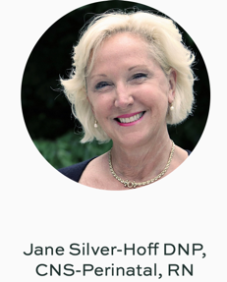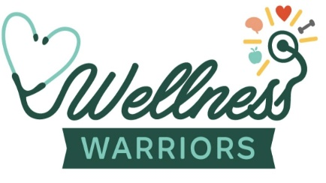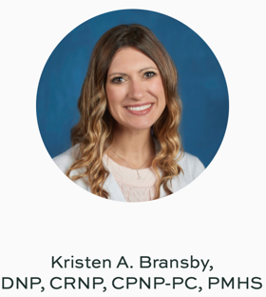

FREE NCPD contact hours!

- Drug use in the United States has reached crisis levels with 1 in 10 people aged 12 and older that meet the criteria for a substance use disorder (O’Brien et al., 2019).
- Nurses, who make up 74.6% of the healthcare workforce, have less than 0.1% specialty in identifying patients in need of substance use care (O’Brien et al., 2019).
- Since the COVID-19 Pandemic has prevented many healthcare providers from attending professional conferences, unique opportunities must be created to provide information and training for healthcare providers at the frontline.

What can you do to help your patients and professional development?

A downloadable three-part miniseries podcast from Apple™ podcasts:

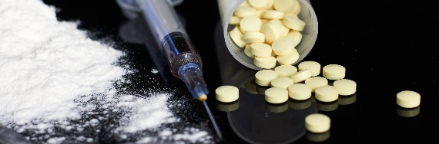

Screening, Brief Intervention, and Referral to Treatment:
Teaching Frontline Nurses

Part 1: What is SBIRT?
Part 2: Screening and the Brief Intervention.
Part 3: The Interview: Role playing an example

- Available to healthcare providers is a website with screening tool information, research articles, a blog, and a direct link for registered nurses to receive FREE NCPD contact hours!

Go here for the PODCAST and NCPD Contact Hours: www.wellnesswarriors.healthcare

The Mentor-Facilitated Training Award Dissemination Project was funded by NIDA CTN DI in partnership with the National Institute on Drug Abuse and the American Association of Colleges of Nursing (AACN)

Pennsylvania State University Ross and Carol Nese College of Nursing is approved as a provider of nursing continuing professional development by the Pennsylvania State Nurses Association, an accredited approver by the American Nurses Credentialing Center’s Commission on Accreditation. RNs who attend all three sessions and complete the pre and post evaluation are eligible to receive 2.0 contacts hours through 12/31/2021.

