GPA Calculation
English HESIA2
Math HESIA2
Previous Degree
Total points=

40 nursing spots. Out of the 40 nursing spots, 24 are reserved for CEP x 2

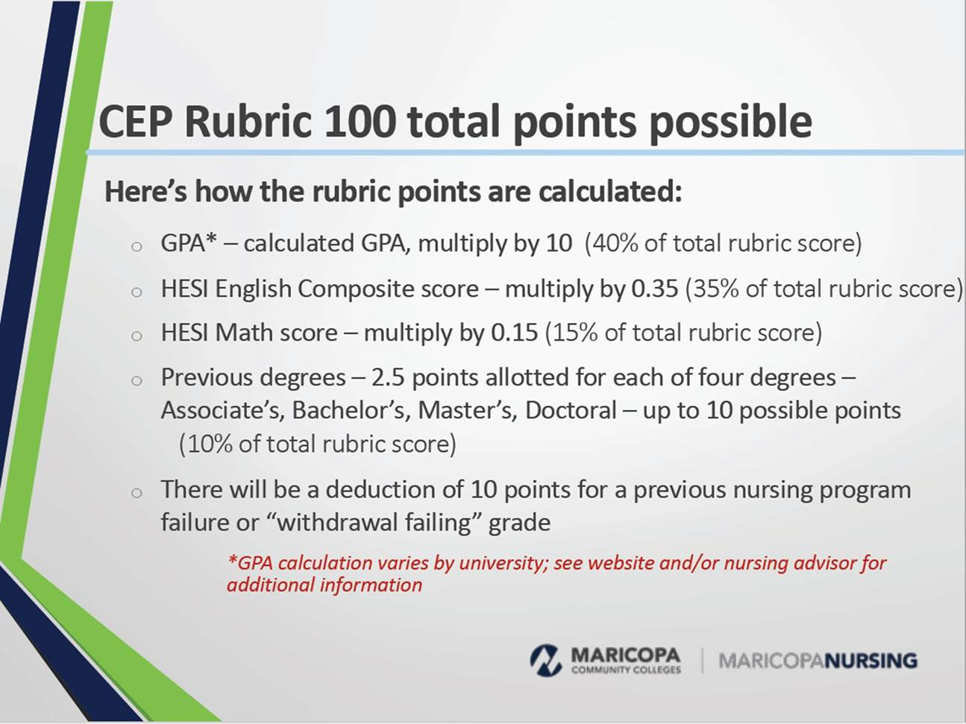

HESI A2 ENGLISH POINT SYSTEM:
100%= 35 points
99%= 34.65 points
98%=34.30 points
97%= 33.95 points
96%=33.60 points
95%= 33.25 points
94%= 32.95 points
93%= 32.55 points
92%=32.20 points
91%=31.85 points
90%=31.50 points

HESI A2 MATH POINT SYSTEM:
100%= 15 points
99%= 14.85 points
98%=14.70 points
97%= 14.55 points
96%= 14.40 points
95%= 14.25 points
94%=14.10 points
93%= 13.95 points
92%= 13.80 points
91%= 13.65
90%= 13.50 points

Maricopa Pre-requisites
Course | Credits
CHM 130/130LL or HS CHM | 0-4
BIO 156/BIO 181 or 1 year HS BIO | 0-4
MAT 140 or higher | 3 to 5
ENG 101 * | 3
BIO 201 * | 4
BIO 202 * | 4
BIO 205 * | 4
PSY 101 or PSY 240 * | 3
ENG 102 * | 3
Humanities | 2
CRE 101- or Test Exempt | 0-3
GCU Co Requisites
HCR 240 * | 4

GCU e-books= $1,200 ($120 x 10 courses)

