ATTENTION!
INCOMING LEVEL 1 STUDENTS

My name is Jordan Begala, I am in the Fall 2020 cohort and have SUPPLIES for anyone who is interested - I know how confused and disoriented you probably feel jumping into your first semester of nursing school! Believe me when I tell you, what I have to offer will be SO HELPFUL throughout your semester – let me explain.

RNSG 1216 – Professional Nursing Competencies is your skills lab class. In this class you will learn all about how to give meds, start IV’s, Insert a foley catheter and so much more! There are 4 main skills you will be tested on – Medication Administration, IV Start/ Stop, Sterile Dressing Change, and Inserting/ Removing Indwelling Urinary Catheter.
Due to COVID, your practice time in the lab is limited, so I made it my mission to replicate the lab in my room! – I have EVERY SUPPLY you could possibly need to practice FULLY at home.

The skills bag that you purchase at the beginning of the semester comes with lots of helpful supplies, however I have items that DO NOT come in your skills bag! (all of which will be listed below)

I understand this may be overwhelming at first, and you are already spending lots of money to get started in this program, but hear me out… The use you will get out of these supplies will DEFINITELY impact your success on these tests.

Below you will find 5 separate packages for sale, however I am willing to sell individual items or everything all together! Feel free to reach out and we can come up with something that works!
All of these supplies are priced at LEAST 50% OFF from the price I purchased them at, and I would be willing to negotiate even lower! – I honestly just want to clear out my room since I no longer need them, and I figured someone from the incoming cohort would get some use out of it.

You can contact me anytime about the supplies or if you have any questions about school in general!
Jordan Begala
214-592-3310
Jbegala1@collin.edu

MEDICATION ADMINISTRATION PACKAGE - $15
- Unit dose medications (these are just allergy pills I labeled as practice meds)
- Food tray
- Fentanyl patches
- Injectable skin (2 types)
- Biohazard box (also useful for IV start/ stop)
- Practice patient binder (story page, MAR, Doctors Orders, and Labs – exactly how it is set up during the test!)
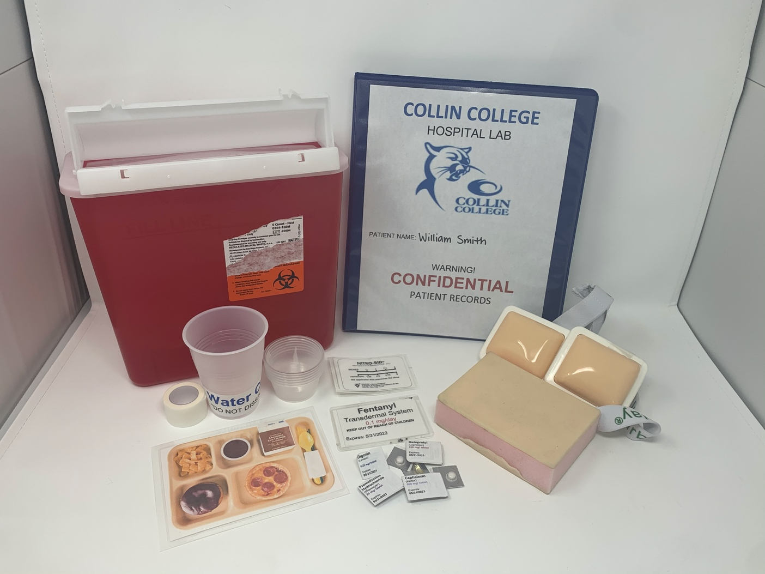

This skill is all about something called “MED CHECKS” – don’t worry, you will become oh too familiar with them very soon!

I created the unit dose and transdermal medications so that you could actually practice checking the date, dose, medication, etc.

The injectable skin will come in handy for the injections portion of the skill! (subcutaneous, intradermal, and intramuscular) – your skills pack that was ordered through the school will have all your needles, vials, syringes, etc.

IV START/ STOP PACKAGE - $45
- Practice arm
- Tegaderm dressings
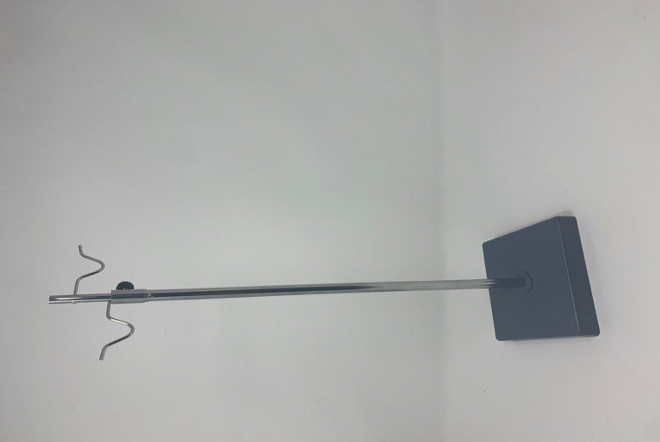
- Waterproof pad
- Sterile gauze pads
- Tourniquets
- Earplugs (you will use these to plug up your IV bags so you can reuse them)
- Labels
- IV pole (tabletop and full sized)
- Practice patient binder (story page, Doctors Orders, and Labs – exactly how it is set up during the test!)
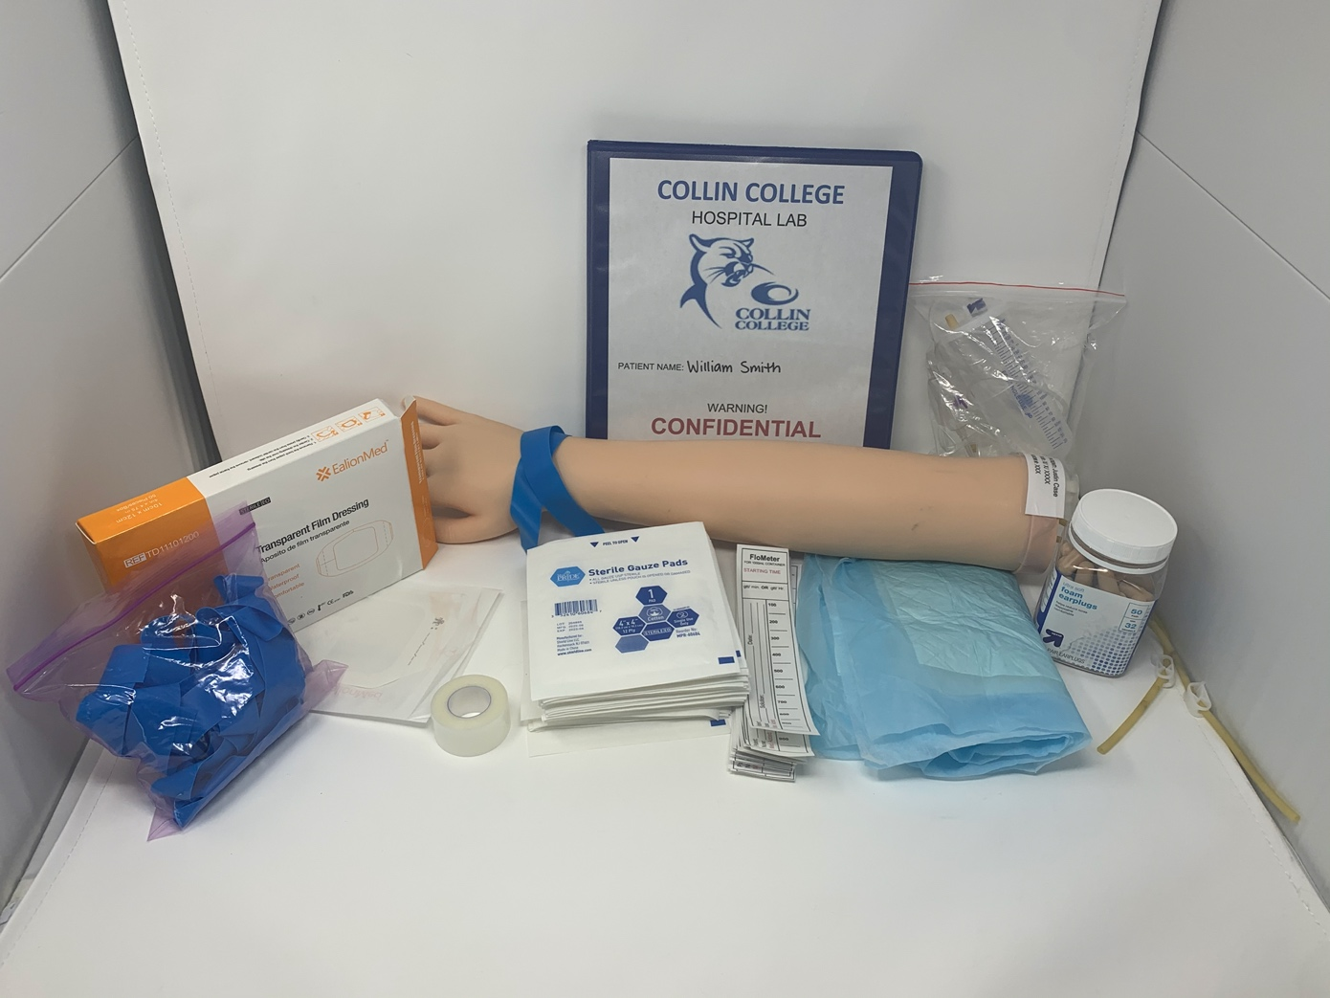

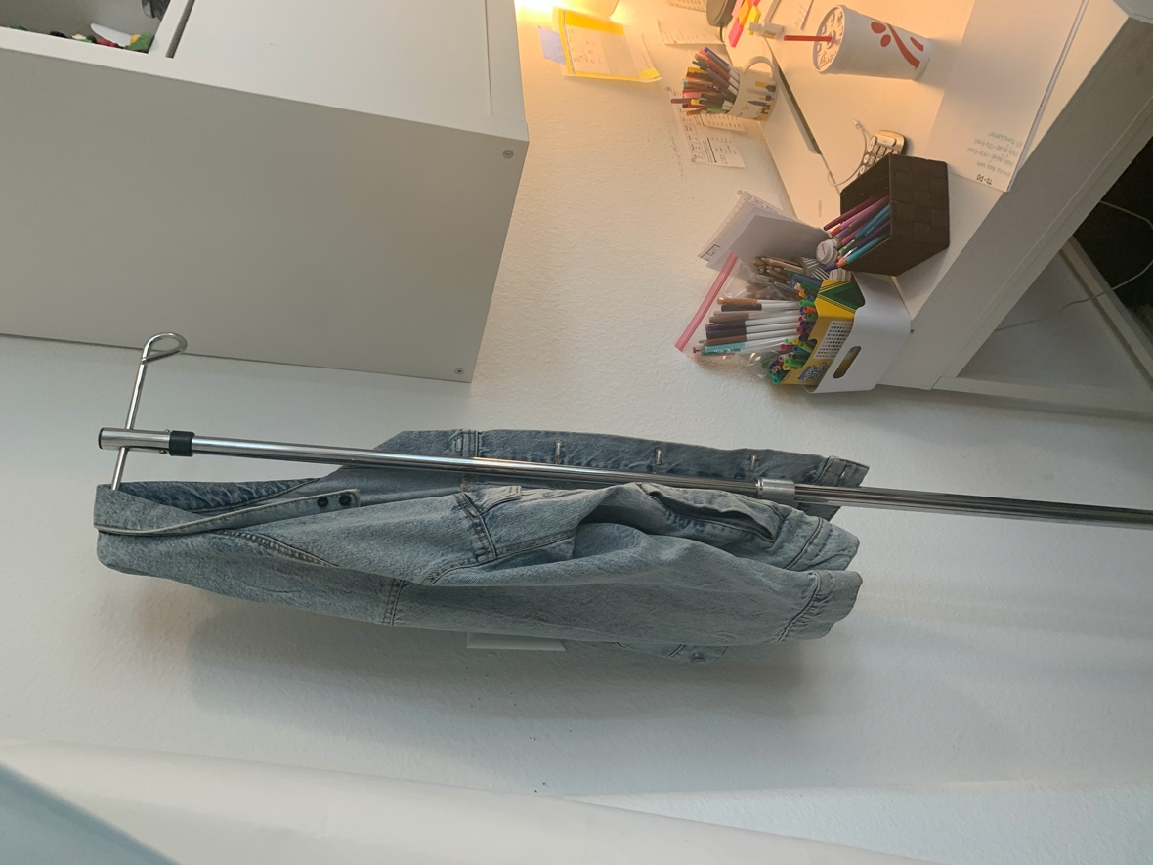

This practice arm is FANTASTIC – all you have to do is add red colored
water through the tubing (using supplies provided) and you have a functioning arm!

IV needles, tubing, and saline bags will come in your skills pack that you purchased!

I hand made the Flowmeter labels and they are exactly like the ones in lab!

My apologies, the IV pole has become a coat rack at the moment, but it is a full sized IV pole with wheels and hooks just like you will use in lab!
STERILE DRESSING CHANGE PACKAGE - $15
- Abdominal Pads
- Sterile gauze pads
- Sterile gloves (this is GOLD I promise)
- Practice wound
- Sterile water
- Practice patient binder (story page, Doctors Orders, and Labs – exactly how it is set up during the test!)
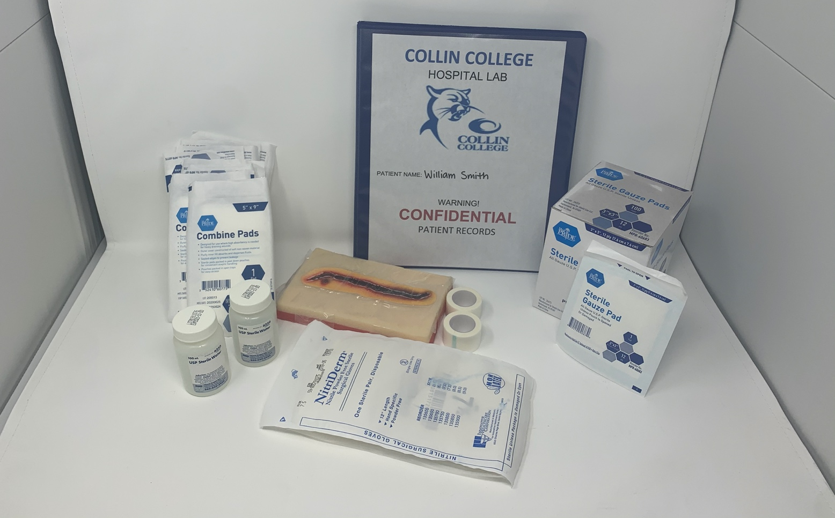

This skill is all about STERILITY! – it requires lots of focus and practice.

The fake wound is homemade and is the perfect size to lay on the abdomen or anywhere else so you can practice just like in lab!

Sterile gloves are more valuable than GOLD, I promise. So much so, that I only have 2-3 pairs and they have been opened. – you can repackage them and use them again however you will only get a pair or two in lab!
(if you look on amazon, a pack of about 45 gloves will run you about $120+)

If I learned anything from this skill it’s to SAVE YOUR STERILE GLOVES, you’re going to use them for your last test.

URINARY CATHETER PACKAGE - $25
- 3 Drainage bags
- 9 Foley catheters
- Drapes (fenestrated and regular)
- 2 Thigh straps
- 3D PRINTED female/ male urethral openings
- Lubricant
- Trays (so you can build your own kit!)
- Practice patient binder (story page, Doctors Orders, and Labs – exactly how it is set up during the test!)
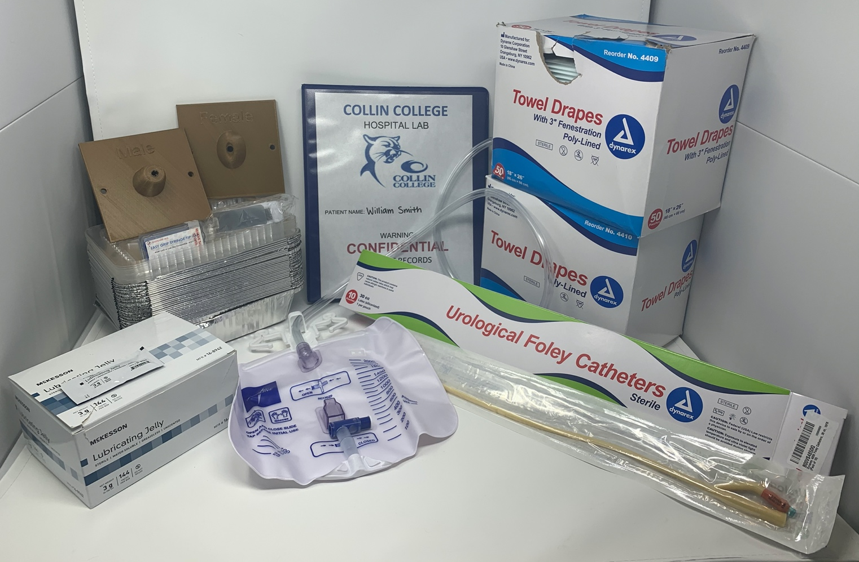

This skill is no joke… out of ALL of the skills, this one definitely requires the most practice!

My dad was awesome enough to 3D print the two models to practice inserting the catheter with!
I would tie them in between the legs of the skeleton, and it made for the PERFECT practice set up!

Reusing supplies becomes very difficult – drapes don’t lay right; catheters get stuck in the wrapper and so much more! The best way to practice a physical skill is to practice RIGHT! These supplies will definitely help you do that.

MISC. PACKAGE - $10
- Medical tape
- Life Size Skeleton (with name band and gown)
- Bone box
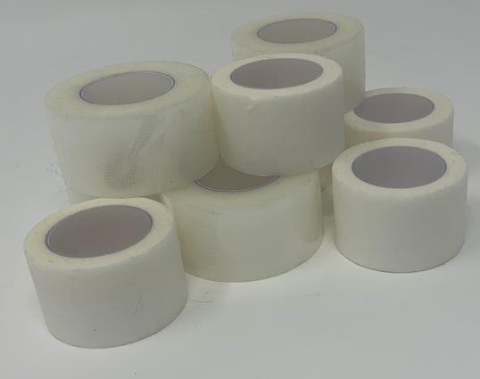

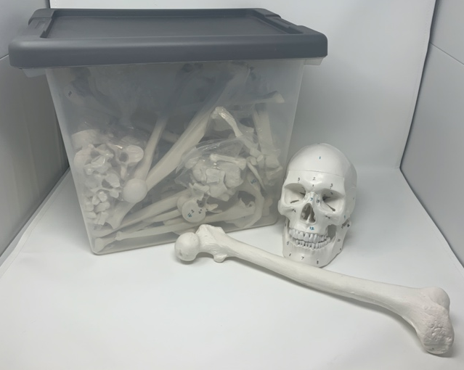
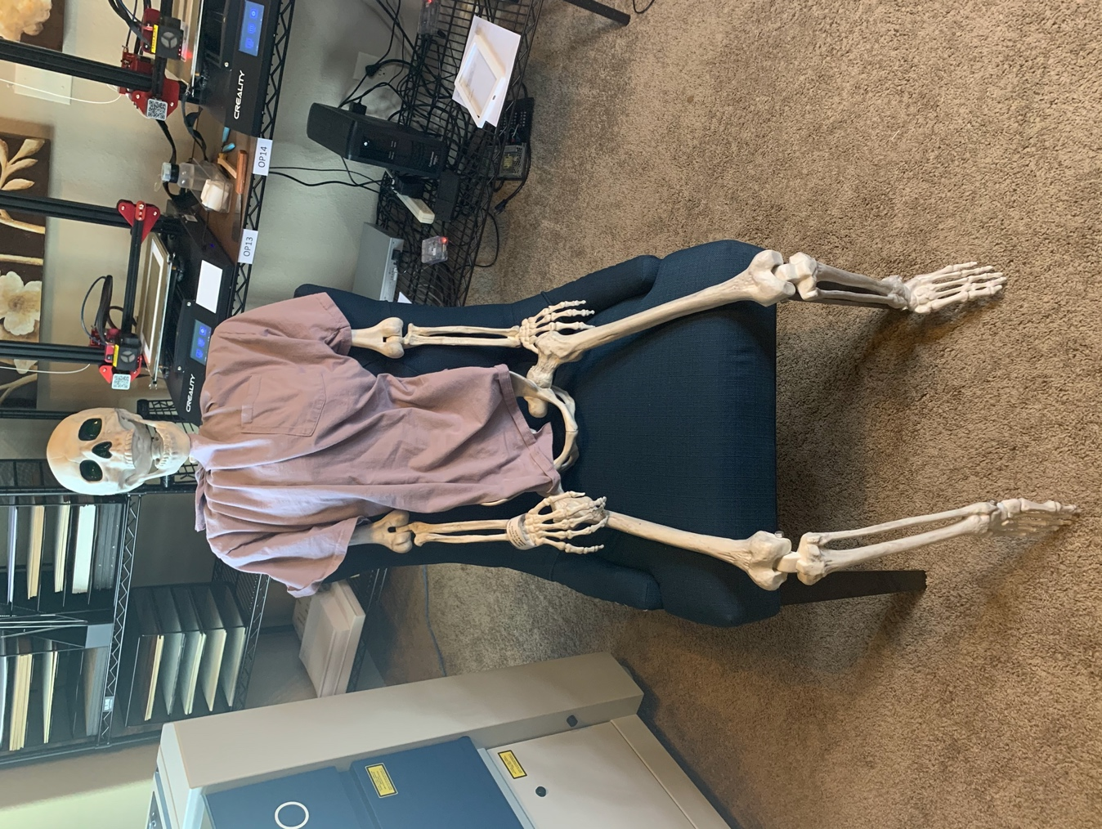

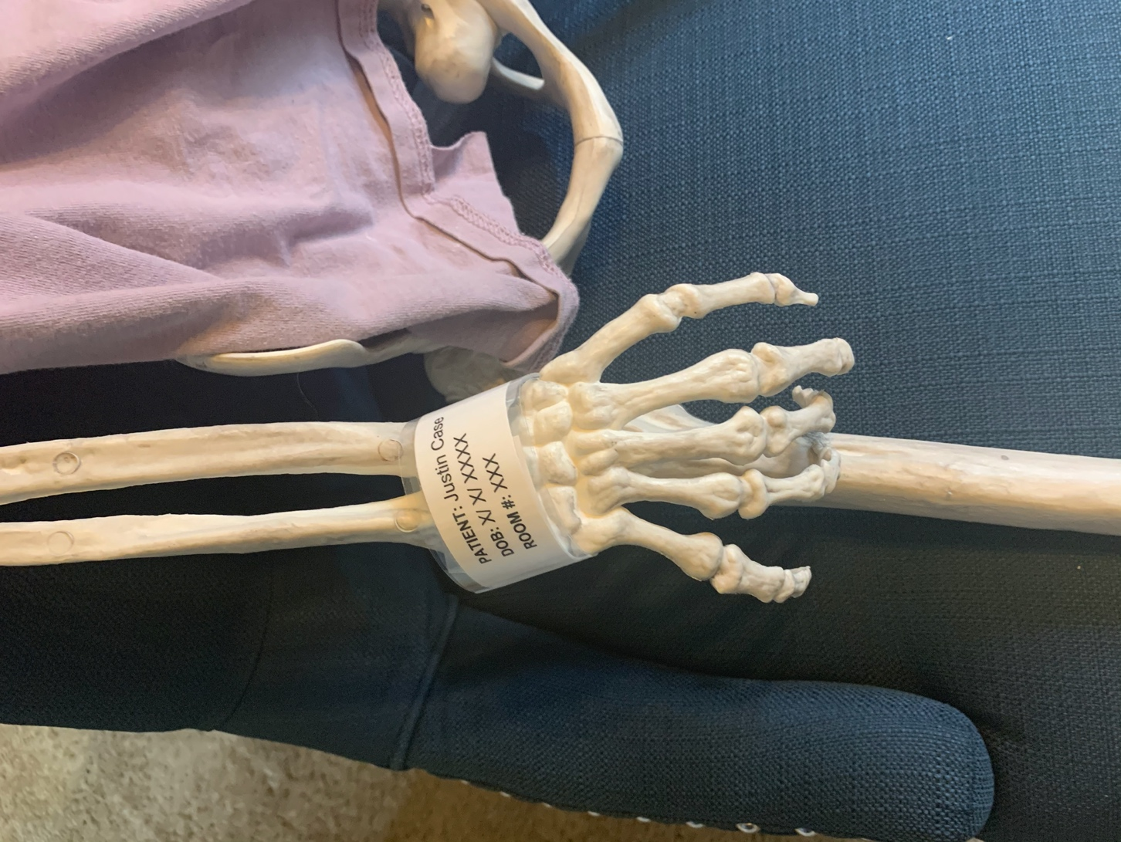

The skeletons name is Justin Case, and he has been the BEST practice patient this semester!
Obviously, a skeleton is not the exact same thing as the mannequins they have in lab, but it is most likely the closest thing you could get! Especially since you can’t inject medication or insert a catheter on your family members hahaha! – I gave him a name band, made him a gown, and I’m sure he will be extremely useful!

The “bone box” is a disarticulated skeleton I purchased for A&P 2 – it most likely won’t be of any use to you anymore, but if you want it or know of anyone in A&P 2 that might want it please let me know!

THE WHOLE BUNDLE (all packages) - $100

Ultimately, I am just trying to clear out these supplies that I don’t need anymore, and I am sure they will be SUPER helpful for any student.

As I stated earlier, I am completely open to talking about pricing, selling individual Items, or just offering some advice/ answering questions you may have!

GOODLUCK in your first semester, you will do GREAT!

Jordan Begala
214-592-3310
Jbegala1@collin.edu

