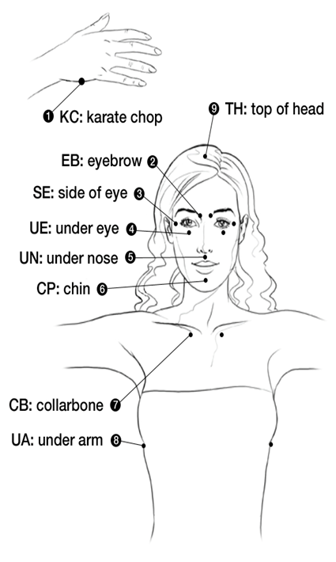
Tapping Points
‘Tapping for Stress Relief’
By Nick Ortner
The Tapping Solution

Rate how stressed you are on a scale from 0 to 10. 10 being extremely stressed. 0 being totally relaxed. Write down that number.

EB: Even though people around me may be feeling stressed
SE: I stay calm.
UE: The calmer I feel the more powerful I am.
UN: Today I am conscious of how I react
C: I can take a step back.
CB: I have a clear view of this situation.
UA: I am resourceful.
TH: This is easier than I thought.

EB: As I react differently to this situation
SE: This situation changes.
UE: What happens doesn’t matter
UN: It’s how I respond that matters.
C: I choose to be centered and calm.
CB: I feel the inner strength inside of me.
UA: I have an inner knowing
TH: That everything will be okay.

EB: No one can make me feel a certain way
SE: It’s all my choice.
UE: And I choose faith
UN: I choose joy
C: I choose laughter
CB: I choose love.
UA: Today I choose.
TH: What do I want this day to be like?

EB: Today is a gift
SE: I’m grateful to be alive.
UE: And to have this day
UN: I refuse to waste it
C: By complaining about what is.
CB: I choose to focus on what I create
UA: I create my reality
TH: I choose wisely.

EB: Today I practice self-care
SE: I’m aware of my needs
UE: I take care of my body
UN: I take care of my mind
C: I stand strong in my power.
CB: And I make decisions that serve me
UA: Only I know what’s right for me.
TH: And I take that step forward

EB: I allow stress to leave my body with every exhale.
SE: I’m confident in my abilities whatever comes my way.
UE: I release all these rules around happiness
And I simply allow myself to be happy
UN: By choosing to appreciate all that I have
C: And focusing on what I desire to create.
CB: Today I trust my intuition
UA: Something amazing is about to happen
TH: As I finally let go of this stress I’m aware of all the possibilities that this day holds.

Rate how stressed you are NOW on a scale from 0 to 10. 10 being extremely stressed. 0 being totally relaxed. Write down that number.
What change have you noticed?

