MTSA Clinical Based Questions

Adrenergic Receptors:
  - .A1-Receptors
    - These receptors are present on the postsynaptic membrane of the effector organs and mediate many of the classic effects, originally designated as α-adrenergic, involving constriction of smooth muscle. Activation of α 1 receptors initiates a series of reactions through the G protein activation of phospholipase C, ultimately resulting in the generation of second messengers inositol-1,4,5-trisphosphate (IP3 ) and diacylglycerol (DAG). IP3 initiates the release of Ca 2+ from the sarcoplasmic reticulum into the cytosol, and DAG turns on other proteins within the cell
    - Located on postsynaptic membranes
    - When alpha-1 receptors are stimulated, this initiates the release of calcium from the endoplasmic reticulum into the cytosol within the cell causing bronchoconstriction, vasoconstriction.
    - The most important cardiovascular effect is vasoconstriction, which increases peripheral vascular resistance, left ventricular afterload, and arterial blood pressure.
    - Example: Phenylephrine

  - A2-Receptors
    - These receptors are located primarily on sympathetic presynaptic nerve endings and control the release of norepinephrine. When a sympathetic adrenergic nerve is stimulated, a portion of the released norepinephrine “circles back” and reacts with α 2 receptors on the presynaptic membrane (Figure 6.5). Stimulation of α 2 receptors causes feedback inhibition and inhibits further release of norepinephrine from the stimulated adrenergic neuron. This inhibitory action serves as a local mechanism for modulating norepinephrine output when there is high sympathetic activity. [Note: In this instance, by inhibiting further output of norepinephrine from the adrenergic neuron, these receptors are acting as inhibitory autoreceptors.] α 2 receptors are also found on presynaptic parasympathetic neurons. Norepinephrine released from a presynaptic sympathetic neuron can diffuse to and interact with these receptors, inhibiting acetylcholine release. [Note: In these instances, these receptors are behaving as inhibitory heteroreceptors.] This is another mechanism to modulate autonomic activity in a given area. In contrast to α 1 receptors, the effects of binding at α 2 receptors are mediated by inhibition of adenylyl cyclase and by a fall in the levels of intracellular cAMP.
    - These receptors are located on the presynaptic nerve terminals and when stimulated, it inhibits adenylate cyclase activity and causing a decrease in calcium release into the neuron terminal. This decreases the entry of calcium ions which limits subsequent exocytosis of storage of vesicles containing norepinephrine.
    - Examples: Precedex
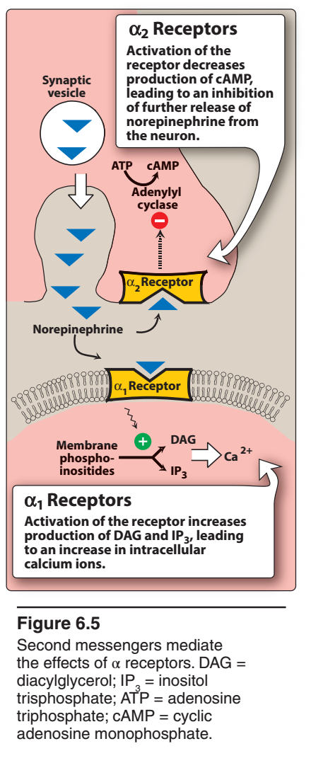

- B-Receptors
  - Responses of β receptors differ from those of α receptors and are characterized by a strong response to isoproterenol, with less sensitivity to epinephrine and norepinephrine. For β receptors, the rank order of potency is isoproterenol > epinephrine > norepinephrine. The β-adrenoceptors can be subdivided into three major subgroups, β 1, β 2 , and β 3 , based on their affinities for adrenergic agonists and antagonists. β 1 receptors have approximately equal affinities for epinephrine and norepinephrine, whereas β 2 receptors have a higher affinity for epinephrine than for norepinephrine. Thus, tissues with a predominance of β 2 receptors (such as the vasculature of skeletal muscle) are particularly responsive to the effects of circulating epinephrine released by the adrenal medulla. β 3 receptors are involved in lipolysis and also have effects on the detrusor muscle of the bladder. Binding of a neurotransmitter at any of the three types of β receptors results in activation of adenylyl cyclase and increased concentrations of cAMP within the cell.
  - Beta 1:
    - Located on the postsynaptic membrane in the heart. Stimulation of these receptors activates adenylate cyclase, which converts adenosine triphosphate to cyclic adenosine monophosphate and initiates a kinase chronotropic (increased heart rate), dromotropic (increased conduction), and inotropic (increased contractility).
    - Examples: Dobutamine, Epinephrine
  - Beta 2:
    - Located primarily on postsynaptic adrenoreceptors located in smooth muscles and glands. They share a common mechanism of action with beta 1 receptors: adenylate cyclase activation. Despite this commonality, B2 stimulation relaxes smooth muscle, resulting in bronchodilation, vasodilation.
    - Epinephrine
  - Beta 3:
    - Found in the gallbladder and brain adipose tissue. Their role in gallbladder physiology is unknown, but they are thought to play a role in lipolysis and thermogenesis in brown fat.
Beta-adrenoceptors are coupled to Gs-proteins, which activate adenylyl cyclase to form cAMP from ATP. Increased cAMP activates a cAMP-dependent protein kinase (PK-A) that phosphorylates L-type calcium channels, which causes increased calcium entry into the cells. Increased calcium entry during action potentials leads to enhanced release of calcium by the sarcoplasmic reticulum in the heart; these actions increase inotropy (contractility). Gs-protein activation also increases heart rate by opening ion channels responsible for pacemaker currents in the sinoatrial node. PK-A phosphorylates sites on the sarcoplasmic reticulum, which enhances the release of calcium through the ryanodine receptors (ryanodine-sensitive, calcium-release channels) associated with the sarcoplasmic reticulum. This provides more calcium for binding the troponin-C, which enhances inotropy. Finally, PK-A can phosphorylate myosin light chains, which may also contribute to the positive inotropic effect of beta-adrenoceptor stimulation. In summary, the cardiac effects of a β-agonist are increased heart rate, contractility, conduction velocity, and relaxation rate.
These receptors, like those in the heart, are coupled to a Gs-protein, which stimulates the formation of cAMP. Although increased cAMP enhances cardiac myocyte contraction (see above), in vascular smooth muscle an increase in cAMP leads to smooth muscle relaxation. The reason for this is that cAMP inhibits myosin light chain kinase that is responsible for phosphorylating smooth muscle myosin. Therefore, increases in intracellular cAMP caused by β₂-agonists inhibits myosin light chain kinase thereby producing less contractile force (i.e., promoting relaxation).

- Dopaminergic Receptors
    - Dopamine (DA) receptors are a group of adrenergic receptors that are activated by dopamine; these receptors are classified as D1 and D2 receptors. Activation of D1 receptors mediates vasodilation in the kidney, intestine, and heart. D2 receptors are believed to play a role in the antiemetic action of droperidol.

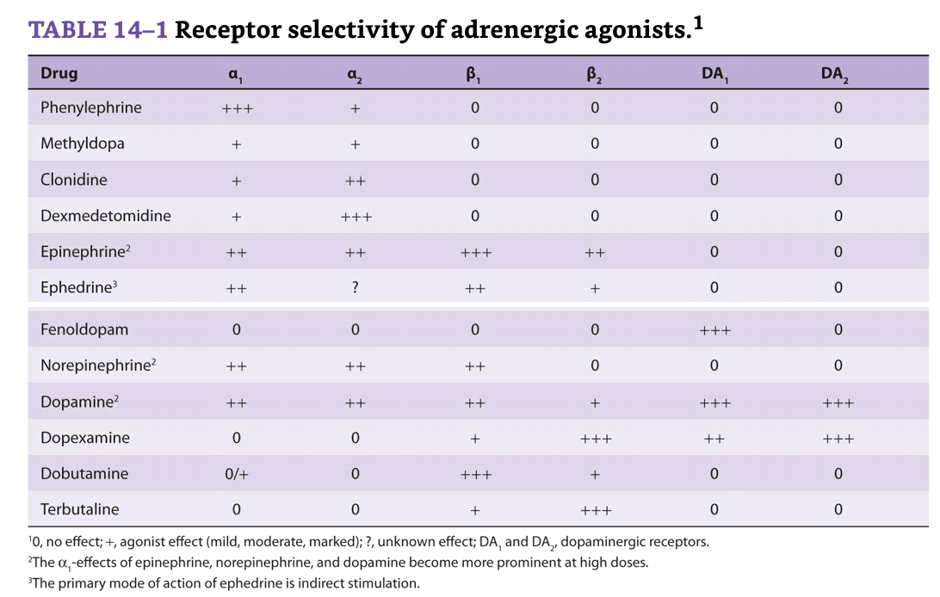
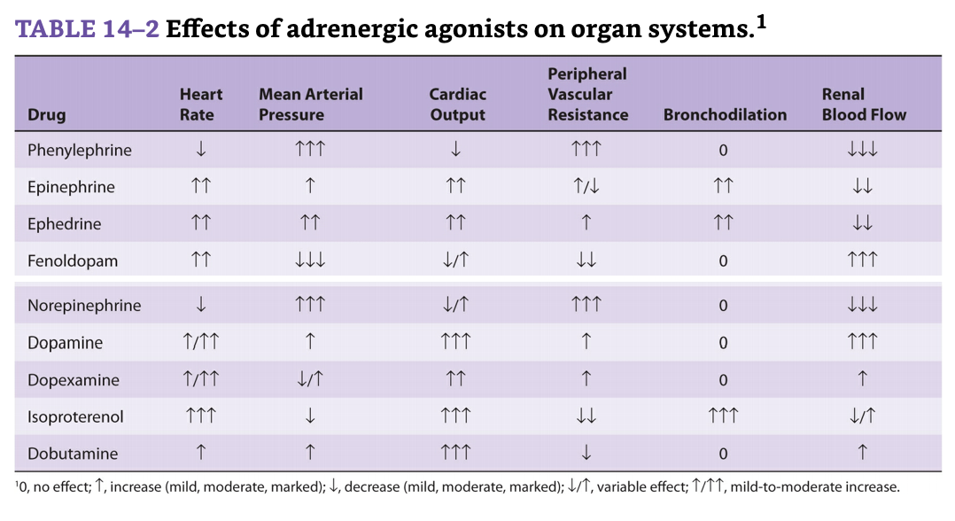
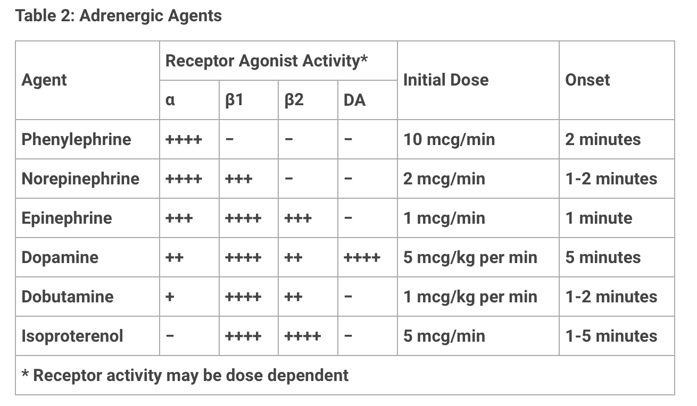

- Vasopressors:

  - ***Phenylephrine
    - Phenylephrine [fen-ill-EF-reen] is a direct-acting, synthetic adrenergic drug that binds primarily to α 1 receptors. Phenylephrine is a vasoconstrictor that raises both systolic and diastolic blood pressures. It has no effect on the heart itself but, rather, induces reflex bradycardia when given parenterally. The drug is used to treat hypotension in hospitalized or surgical patients (especially those with a rapid heart rate). Large doses can cause hypertensive headache and cardiac irregularities. Phenylephrine acts as a nasal decongestant when applied topically or taken orally. Phenylephrine has replaced pseudoephedrine in many oral decongestants, since pseudoephedrine has been misused to make methamphetamine. Phenylephrine is also used in ophthalmic solutions for mydriasis.
    - Receptor -> A1
    - Main Use -> Hypotension (often used as a push dose in the ED and OR)
    - Effect -> Vasoconstriction

  - Ephedrine
    - The cardiovascular effects of ephedrine, a non-catecholamine sympathomimetic, are similar to those of epinephrine: increase in blood pressure, heart rate, contractility, and cardiac output. Likewise, it is also a bronchodilator. There are important differences, however: ephedrine has a longer duration of action, is much less potent, has indirect and indirect actions, and stimulates the central nervous system (it raises minimum alveolar concentration). The indirect agonist properties of ephedrine may be due to peripheral postsynaptic norepinephrine release, or by inhibition of norepinephrine reuptake.
    - Ephedrine is commonly used as a vasopressor during anesthesia. As such, its administration should be viewed as a temporizing measure while the cause of hypotension is determined and remedied. Unlike direct-acting a1-agonists, ephedrine is believed not to decrease uterine blood flow, and thus was regarded as the preferred vasopressor in obstetric uses. Recently, however, phenylephrine has been argued to be a better vasopressor in obstetric patients undergoing neuroaxial anesthesia due to its faster onset, shorter duration of action, and better titratability and maintenance of fetal pH. Also has been reported to have antiemetic properties, particularly in association with hypotension following spinal anesthesia.

  - ***Vasopressin
    - Vasopressin [vas-oh-PRESS-in] (antidiuretic hormone) is structurally related to oxytocin. Vasopressin has both antidiuretic and vasopressor effects (Figure 24.6). In the kidney, it binds to the V2 receptor to increase water permeability and reabsorption in the collecting tubules. Thus, the major use of vasopressin is to treat diabetes insipidus. It also finds use in the management of cardiac arrest and in controlling bleeding due to esophageal varices. Other effects of vasopressin are mediated by the V1 receptor, which is found in liver, vascular smooth muscle (where it causes constriction), and other tissues. The major toxicities of vasopressin are water intoxication and hyponatremia. Abdominal pain, tremor, and vertigo can also occur. Desmopressin [des-moePRESS-in], an analog of vasopressin, has minimal activity at the V1 receptor, making it largely free of pressor effects. This analog is longer acting than vasopressin and is preferred for the treatment of diabetes insipidus and nocturnal enuresis. For these indications, desmopressin may be administered intranasally or orally. [Note: The nasal spray should not be used for enuresis due to reports of seizures in children using this formulation.] Local irritation may occur with the nasal spray.
    - V1 receptors are found on vascular smooth muscle of the systemic, splanchnic, renal, and coronary circulations. They are also located on myometrium and platelets. These G-protein- coupled receptors activate phospholipase C via Gq G-protein, which ultimately leads to an increase in intracellular calcium. The major effect is to induce vasoconstriction, the magnitude of which is dependent on the vascular bed. In the pulmonary circulation, vasodilation is produced via nitric oxide release.
    - V2 receptors are predominantly located in the distal tubule and collecting ducts of the kidney. These G-protein-coupled receptors stimulate Gs G-protein to activate adenylate cyclase, increasing CAMP, causing the mobilization of aquaporin channels. These channels insert into the apical membrane of the distal tubules and collecting duct cells. V2 receptors are essential for plasma volume and osmolality control. Their presence on endothelial cells induces the release of Von Willebrand Factor (VWF) and Factor VIII:coagulant (FVIII:c). VWF protects FVIII from breakdown in plasma and is important in binding platelets to the site of bleeding.
    - V3 receptors are found mainly in the pituitary. They are Gq-coupled G-protein receptors which increase intracellular calcium when activated. They are thought to be involved in ACTH release and may act as a neurotransmitter or mediator involved with memory consolidation or retrieval and body temperature regulation.1, 2
    - Receptor -> V1
    - Main Effect -> Vasoconstriction
    - Main Use -> Adjunct to Norepinephrine, sparing effect @low doses.

  - Epinephrine
    - Epinephrine [ep-i-NEF-rin] is one of the four catecholamines (epinephrine, norepinephrine, dopamine, and dobutamine) commonly used in therapy. The first three are naturally occurring neurotransmitters, and the latter is a synthetic compound. In the adrenal medulla, norepinephrine is methylated to yield epinephrine, which is stored in chromaffin cells along with norepinephrine. On stimulation, the adrenal medulla releases about 80% epinephrine and 20% norepinephrine directly into the circulation. Epinephrine interacts with both α and β receptors. At low doses, β effects (vasodilation) on the vascular system predominate, whereas at high doses, α effects (vasoconstriction) are the strongest.
      - Cardiovascular: The major actions of epinephrine are on the cardiovascular system. Epinephrine strengthens the contractility of the myocardium (positive inotrope: β 1 action) and increases its rate of contraction (positive chronotrope: β 1 action). Therefore, cardiac output increases. These effects increase oxygen demands on the myocardium. Epinephrine activates β 1 receptors on the kidney to cause renin release. Renin is an enzyme involved in the production of angiotensin II, a potent vasoconstrictor. Epinephrine constricts arterioles in the skin, mucous membranes, and viscera (α effects), and it dilates vessels going to the liver and skeletal muscle (β 2 effects). Renal blood flow is decreased. Therefore, the cumulative effect is an increase in systolic blood pressure, coupled with a slight decrease in diastolic pressure due to β 2 receptor–mediated vasodilation in the skeletal muscle vascular bed (Figure 6.9).
      - Respiratory: Epinephrine causes powerful bronchodilation by acting directly on bronchial smooth muscle (β 2 action). It also inhibits the release of allergy mediators such as histamines from mast cells.
    - Therapeutic uses:
      - Bronchospasm: Epinephrine is the primary drug used in the emergency treatment of respiratory conditions when bronchoconstriction has resulted in diminished respiratory function. Thus, in treatment of acute asthma and anaphylactic shock, epinephrine is the drug of choice and can be life saving in this setting. Within a few minutes after subcutaneous administration, respiratory function greatly improves. However, selective β 2 agonists, such as albuterol, are favored in the chronic treatment of asthma because of a longer duration of action and minimal cardiac stimulatory effects.
    - Anaphylactic shock:
      - Epinephrine is the drug of choice for the treatment of type I hypersensitivity reactions (including anaphylaxis) in response to allergens.
    - Cardiac arrest:
      - Epinephrine may be used to restore cardiac rhythm in patients with cardiac arrest.
    - Anesthetics:
      - Local anesthetic solutions may contain low concentrations (for example, 1:100,000 parts) of epinephrine. Epinephrine greatly increases the duration of local anesthesia by producing vasoconstriction at the site of injection. This allows the local anesthetic to persist at the injection site before being absorbed into the systemic circulation. Very weak solutions of epinephrine can also be applied topically to vasoconstrict mucous membranes and control oozing of capillary blood.
    - Pharmacokinetics:
      - Epinephrine has a rapid onset but a brief duration of action (due to rapid degradation). The preferred route is intramuscular (anterior thigh) due to rapid absorption. In emergency situations, epinephrine is given intravenously (IV) for the most rapid onset of action. It may also be given subcutaneously, by endotracheal tube, and by inhalation (Figure 6.10). It is rapidly metabolized by MAO and COMT, and the metabolites metanephrine and vanillylmandelic acid are excreted in urine.
      - Receptors -> A1, A2, B1, B2
      - Main Effect -> Vasoconstriction, Ionotropy, Dromotropy, Chronotropy
      - Main Use -> AAA: Anaphylaxis, Asthma, Arrest

  - ***Norepinephrine
    - Because norepinephrine is the neurotransmitter of adrenergic nerves, it should, theoretically, stimulate all types of adrenergic receptors. However, when administered in therapeutic doses, the α-adrenergic receptor is most affected.
    - Cardiovascular actions:
      - Vasoconstriction: Norepinephrine causes a rise in peripheral resistance due to intense vasoconstriction of most vascular beds, including the kidney (α 1 effect). Both systolic and diastolic blood pressures increase (Figure 6.11). [Note: Norepinephrine causes greater vasoconstriction than epinephrine, because it does not induce compensatory vasodilation via β 2 receptors on blood vessels supplying skeletal muscles. The weak β 2 activity of norepinephrine also explains why it is not useful in the treatment of asthma or anaphylaxis.]
    - Baroreceptor reflex:
      - Norepinephrine increases blood pressure, and this stimulates the baroreceptors, inducing a rise in vagal activity. The increased vagal activity produces a reflex bradycardia, which is sufficient to counteract the local actions of norepinephrine on the heart, although the reflex compensation does not affect the positive inotropic effects of the drug (Figure 6.11). When atropine, which blocks the transmission of vagal effects, is given before norepinephrine, stimulation of the heart by norepinephrine is evident as tachycardia.
      - An endogenous catecholamine synthesized from dopamine in adrenergic postganglionic nerves and in adrenal medullary cells (where it is both secreted and serves as a precursor of epinephrine). Through its β1 activity, norepinephrine has positive inotropic and chronotropic effects. Acting at peripheral α-receptors, it is also a potent vasoconstrictor. The increase in total peripheral resistance causes the mean arterial blood pressure to rise. With these effects, norepinephrine is useful in patients suffering from “warm shock,” in which the combination of cardiac contractile dysfunction and peripheral vasodilation lowers blood pressure. However, the intense vasoconstriction elicited by this drug makes it less attractive than others in treating most other types of shock. Norepinephrine’s side effects include precipitation of myocardial ischemia (because of the augmented force of contraction and increased afterload) and tachyarrhythmias.
    - Pharmacokinetics:
      - Norepinephrine is given IV for rapid onset of action. The duration of action is 1 to 2 minutes, following the end of the infusion. It is rapidly metabolized by MAO and COMT, and inactive metabolites are excreted in the urine.
    - Receptors -> A1, B1
    - Main Effect -> Vasoconstriction, Ionotropy
    - Main Use -> Septic Shock

  - ***Dopamine
    - The immediate metabolic precursor of norepinephrine, occurs naturally in the CNS in the basal ganglia, where it functions as a neurotransmitter, as well as in the adrenal medulla. Dopamine can activate α- and β-adrenergic receptors. For example, at higher doses, it causes vasoconstriction by activating α 1 receptors, whereas at lower doses, it stimulates β 1 cardiac receptors. In addition, D1 and D2 dopaminergic receptors, distinct from the α- and β-adrenergic receptors, occur in the peripheral mesenteric and renal vascular beds, where binding of dopamine produces vasodilation. D2 receptors are also found on presynaptic adrenergic neurons, where their activation interferes with norepinephrine release.
    - Cardiovascular:
      - Dopamine exerts a stimulatory effect on the β 1 receptors of the heart, having both positive inotropic and chronotropic effects (Figure 6.13). At very high doses, dopamine activates α 1 receptors on the vasculature, resulting in vasoconstriction. b. Renal and visceral: Dopamine dilates renal and splanchnic arterioles by activating dopaminergic receptors, thereby increasing blood flow to the kidneys and other viscera (Figure 6.13). These receptors are not affected by α- or β-blocking drugs. Therefore, dopamine is clinically useful in the treatment of shock, in which significant increases in sympathetic activity might compromise renal function.
    - Therapeutic uses:
      - Dopamine is the drug of choice for cardiogenic and septic shock and is given by continuous infusion. It raises blood pressure by stimulating the β 1 receptors on the heart to increase cardiac output and α 1 receptors on blood vessels to increase total peripheral resistance. In addition, it enhances perfusion to the kidney and splanchnic areas, as described above. Increased blood flow to the kidney enhances the glomerular filtration rate and causes diuresis. In this regard, dopamine is far superior to norepinephrine, which diminishes blood supply to the kidney and may cause renal shutdown. It is also used to treat hypotension and severe heart failure, primarily in patients with low or normal peripheral vascular resistance and in patients who have oliguria.
      - Dopamine is an endogenous catecholamine and the precursor of norepinephrine. It possesses an unusual combination of actions that makes it attractive in the treatment of heart failure associated with hypotension and poor renal perfusion. There are various types of receptors with different affinities for dopamine.
      - At low dosages, less than 2 μg/kg/min, dopamine interacts primarily with dopaminergic receptors distributed in the renal and mesenteric vascular beds. Stimulation of these receptors causes local vasodilation and increases renal blood flow and glomerular filtration, facilitating diuresis.
      - Medium dosages of dopamine, 2 to 10 μg/kg/min, increase inotropy directly by stimulating cardiac β1-receptors and indirectly by promoting norepinephrine release from sympathetic nerve terminals. These actions increase heart rate, cardiac contractility, and stroke volume, all of which augment CO.
      - At high dosages, greater than 10 μg/kg/min, dopamine also stimulates systemic α-receptors, thereby causing vasoconstriction and elevating systemic resistance. High-dose dopamine is indicated in hypotensive states such as shock. However, these doses are inappropriate in most patients with cardiac failure because the peripheral vasoconstriction increases the resistance against which the heart contracts (i.e., higher afterload), which could impair left ventricular output.
    - Receptors -> A1, A2, B1, B2, DA
    - Main Effect -> Vasoconstriction (higher doses, Ionotropy, Dromotropy, Chronotropy
    - Main Use -> Hypotension

  - ***Dobutamine
    - Dobutamine is a synthetic, direct-acting catecholamine that is a β 1 receptor agonist. It increases cardiac rate and output with few vascular effects. Dobutamine is used to increase cardiac output in acute heart failure (see Chapter 19), as well as for inotropic support after cardiac surgery. The drug increases cardiac output and does not significantly elevate oxygen demands of the myocardium, a major advantage over other sympathomimetic drugs. Dobutamine should be used with caution in atrial fibrillation, because it increases AV conduction. Other adverse effects are similar to epinephrine. Tolerance may develop with prolonged use.
    - Is a synthetic analog of dopamine that stimulates β1-, β2-, and α-receptors. It increases cardiac contractility by virtue of the β1 effect but does not increase peripheral resistance because of the balance between α-mediated vasoconstriction and β2-mediated vasodilation. Thus, it is useful in the treatment of heart failure not accompanied by hypotension. Unlike dopamine, dobutamine does not stimulate dopaminergic receptors (i.e., no renal vasodilating effect), nor does it facilitate the release of norepinephrine from peripheral nerve endings. Like dopamine, it is useful for short-term therapy (less than 1 week), after which time it loses its efficacy, presumably because of down-regulation of adrenergic receptors. The major adverse effect is the provocation of tachyarrhythmias.
    - Receptor -> B1, B2
    - Main Effect -> Ionotropy, Mild Vasodilation
    - Main Use -> Cardiogenic shock

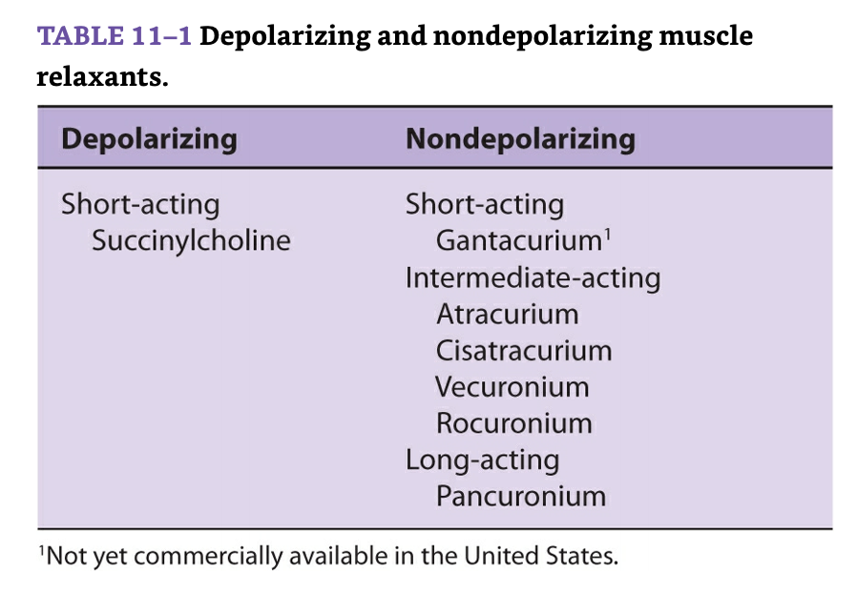
- Paralytics:
  - Succinylcholine
    - The only depolarizing muscle relaxant in clinical use today.
    - Physical structure:
      - Succinylcholine—also called diacetylcholine or suxamethonium—consists of two joined ACh molecules. This structure underlies succinylcholine’s mechanism of action, side effects, and metabolism. The popularity of succinylcholine is due to its rapid onset of action (30–60 s) and short duration of action (typically less than 10 min). Its rapid onset of action relative to other neuromuscular blockers is largely due to the relative overdose that is usually administered. Succinylcholine, like all neuromuscular blockers, has a small volume of distribution due to its very low lipid solubility, and this also underlies a rapid onset of action. As succinylcholine enters the circulation, most of it is rapidly metabolized by pseudocholinesterase into succinylmonocholine. This process is so efficient that only a small fraction of the injected dose ever reaches the neuromuscular junction. As drug levels fall in blood, succinylcholine molecules diffuse away from the neuromuscular junction, limiting the duration of action. However, this duration of action can be prolonged by high doses, infusion of succinylcholine, or abnormal metabolism.
      - Hyperkalemia: Normal muscle releases enough potassium during succinylcholine-induced depolarization to increase serum potassium by 0.5 mEq/L. Although this is usually insignificant in patients with normal baseline potassium levels, it can be life-threatening in patients with preexisting hyperkalemia. The increase in potassium in patients with burn injury, massive trauma, neurological disorders, and several other conditions can be large and catastrophic.
      - Hyperkalemic cardiac arrest can prove to be quite refractory to routine cardiopulmonary resuscitation, requiring calcium, insulin, glucose, bicarbonate, and even cardiopulmonary bypass to support the circulation while reducing serum potassium levels. Following denervation injuries (spinal cord injuries, larger burns), the immature isoform of the ACh receptor may be expressed inside and outside the neuromuscular junction (up-regulation). These extrajunctional receptors allow succinylcholine to effect widespread depolarization and extensive potassium release. Life-threatening potassium release is not reliably prevented by pretreatment with a nondepolarizer. The risk of hyperkalemia usually seems to peak in 7–10 days following the injury, but the exact time of onset and the duration of the risk period vary. The risk of hyperkalemia from succinylcholine is minimal in the first 2 days after spinal cord or burn injury.

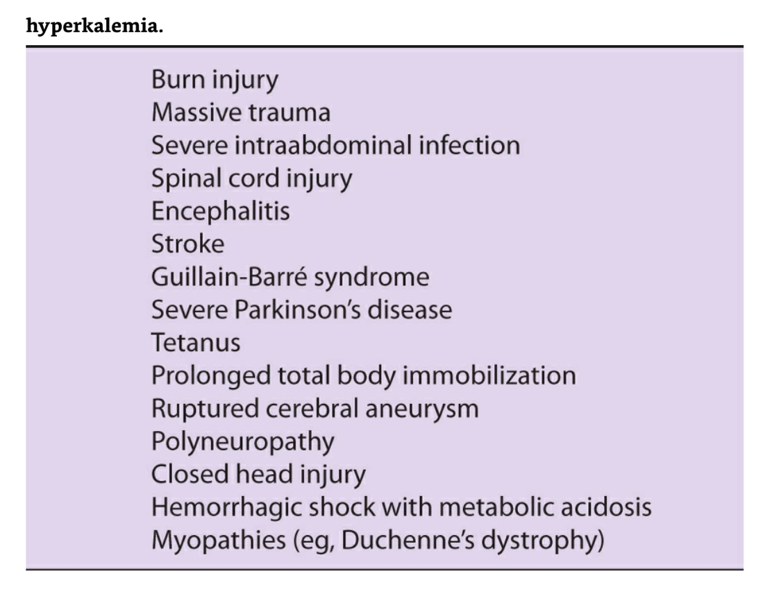

  - Vecuronium
    - Vecuronium is pancuronium minus a quaternary methyl group (a monoquaternary relaxant). This minor structural change beneficially alters side effects without affecting potency.
    - Metabolism & Excretion:
      - Vecuronium is metabolized to a small extent by the liver. It depends primarily on biliary excretion and secondarily (25%) on renal excretion. Although it is a satisfactory drug for patients with renal failure, its duration of action is somewhat prolonged. Vecuronium’s brief duration of action is explained by its shorter elimination half-life and more rapid clearance compared with pancuronium. Long-term administration of vecuronium to patients in intensive care units has resulted in prolonged neuromuscular blockade (up to several days), possibly from accumulation of its active 3-hydroxy metabolite, changing drug clearance, and in some patients, leading to the development of a polyneuropathy. Risk factors seem to include female gender, renal failure, long-term or high-dose corticosteroid therapy, and sepsis. Thus, these patients must be closely monitored, and the dose of vecuronium carefully titrated. Long-term relaxant administration and the subsequent prolonged lack of ACh binding at the postsynaptic nicotinic ACh receptors may mimic a chronic denervation state and cause lasting receptor dysfunction and paralysis. Tolerance to nondepolarizing muscle relaxants can also develop after long-term use. Fortunately, the use of unnecessary paralysis has greatly declined in critical care units.

  - Rocuronium
    - Physical Structure: This monoquaternary steroid analogue of vecuronium was designed to provide a rapid onset of action.
    - Metabolism & Excretion: Rocuronium undergoes no metabolism and is eliminated primarily by the liver and slightly by the kidneys. Its duration of action is not significantly affected by renal disease, but it is modestly prolonged by severe hepatic failure and pregnancy. Because rocuronium does not have active metabolites, it may be a better choice than vecuronium in the rare patient requiring prolonged infusions in the intensive care unit setting. Elderly patients may experience a prolonged duration of action due to decreased liver mass.

  - Etomidate
    - Mechanisms of Action: Etomidate depresses the reticular activating system and mimics the inhibitory effects of GABA. Specifically, etomidate—particularly the R(+) isomer— appears to bind to a subunit of the GABAA receptor, increasing the receptor’s affinity for GABA. Unlike barbiturates, etomidate may have disinhibitory effects on the parts of the nervous system that control extrapyramidal motor activity. This disinhibition offers a potential explanation for the 30–60% incidence of myoclonus with etomidate induction of anesthesia.
    - Structure–Activity Relationships: Etomidate contains a carboxylated imidazole and is structurally unrelated to other anesthetic agents (see Figure 9–4). The imidazole ring provides water solubility in acidic solutions and lipid solubility at physiological pH. Therefore etomidate is dissolved in propylene glycol for injection. This solution often causes pain on injection that can be lessened by a prior intravenous injection of lidocaine.
    - Pharmacokinetics:
      - Absorption: Etomidate is available only for intravenous administration and is used primarily for induction of general anesthesia. It is sometimes used for brief production of deep (unconscious) sedation such as prior to placement of retrobulbar blocks.
      - Biotransformation: Hepatic microsomal enzymes and plasma esterases rapidly hydrolyze etomidate to an inactive metabolite.
      - Excretion: The end products of etomidate hydrolysis are primarily excreted in the urine.
- Sedatives:
  - Propofol
    - Mechanisms of Action: Propofol induction of general anesthesia may involve facilitation of inhibitory neurotransmission mediated by GABAA receptor binding. Propofol allosterically increases binding affinity of GABA for the GABAA receptor. This receptor, as previously noted, is coupled to a chloride channel, and activation of the receptor leads to hyperpolarization of the nerve membrane. Propofol (like most general anesthetics) binds multiple ion channels and receptors. Propofol actions are not reversed by the specific benzodiazepine antagonist flumazenil.
    - Pharmacokinetics:
      - Absorption: Propofol is available only for intravenous administration for the induction of general anesthesia and for moderate to deep sedation (see Table 9–3).
      - Biotransformation: The clearance of propofol exceeds hepatic blood flow, implying the existence of extrahepatic metabolism. This exceptionally high clearance rate probably contributes to relatively rapid recovery after continuous infusions. Conjugation in the liver results in inactive metabolites that are eliminated by renal clearance. The pharmacokinetics of propofol do not appear to be affected by obesity, cirrhosis, or kidney failure. Use of propofol infusion for long-term sedation of children who are critically ill or young adult neurosurgical patients has been associated with sporadic cases of lipemia, metabolic acidosis, and death, the so-termed propofol infusion syndrome.
      - Excretion: Although metabolites of propofol are primarily excreted in the urine, chronic kidney failure does not affect clearance of the parent drug.

  - Versed
    - Midazolam is the principal benzodiazepine used perioperatively. Benzodiazepines provide anxiolysis, sedation, amnesia, and in high doses unconsciousness through GABAA receptor activation and potentiation. Midazolam has minimal myocardial depression. There is no effect on MAP or CO; HR may increase slightly.
    - is lipid soluble and therefore has the most rapid onset and shortest duration of action. Unlike other benzodiazepines, midazolam is both lipid soluble and water soluble and therefore can be manufactured without the pain-inducing solvent propylene glycol. It has a single metabolite with minimal activity. It is by far the most common benzodiazepine used perioperatively.

  - Ketamine
    - Mechanisms of Action: Ketamine has multiple effects throughout the central nervous system, inhibiting polysynaptic reflexes in the spinal cord as well as excitatory neurotransmitter effects in selected areas of the brain. In contrast to the depression of the reticular activating system induced by the barbiturates, ketamine functionally “dissociates” the thalamus (which relays sensory impulses from the reticular activating system to the cerebral cortex) from the limbic cortex (which is involved with the awareness of sensation). Clinically, this state of dissociative anesthesia may cause the patient to appear conscious (eg, eye opening, swallowing, muscle contracture) but unable to process or respond to sensory input. Ketamine has been demonstrated to be an N-methyl-D-aspartate (NMDA) receptor (a subtype of the glutamate receptor) antagonist.
    - Pharmacokinetics:
      - Distribution: Ketamine is more lipid soluble and less protein bound than thiopental. These characteristics, along with ketamine-induced increase in cerebral blood flow and cardiac output, lead to rapid brain uptake and subsequent redistribution (the distribution half-life is 10–15 min). Awakening is due to redistribution from brain to peripheral compartments.
      - Biotransformation: Ketamine is biotransformed in the liver to several metabolites, one of which (norketamine) retains anesthetic activity. Induction of hepatic enzymes only partially explains the tolerance that patients who receive multiple doses of ketamine will develop. Extensive hepatic uptake (hepatic extraction ratio of 0.9) explains ketamine’s relatively short elimination half-life (2 h).
      - Excretion: End products of ketamine biotransformation are excreted renally.

  - Precedex
    - Mechanism of Action: Dexmedetomidine (Precedex) is a parenteral selective α2 agonist with sedative properties. It appears to be more selective for the α2 receptor than clonidine. At higher doses it loses its selectivity and also stimulates α1-adrenergic receptors.
    - Clinical Uses:
      - Dexmedetomidine causes dose-dependent sedation anxiolysis and some analgesia and blunts the sympathetic response to surgery and other stress. Most importantly, it has an opioid-sparing effect and does not significantly depress respiratory drive; excessive sedation, however, may cause airway obstruction. The drug is used for short-term (<24 h), intravenous sedation of mechanically ventilated patients. Discontinuation after more prolonged use can potentially cause a withdrawal phenomenon similar to that of clonidine. It has also been used for intraoperative sedation and as an adjunct to general anesthetics.
    - Side Effects:
      - The principal side effects are bradycardia, heart block, and hypotension. It may also cause nausea.
    - Dosage:
      - The recommended initial loading dose is 1 mcg/kg intravenously over 10 min with a maintenance infusion rate of 0.2–0.7 mcg/kg/h. Dexmedetomidine has a rapid onset and terminal half-life of 2 h. The drug is metabolized in the liver and its metabolites are eliminated in the urine. Dosage should be reduced in patients with renal insufficiency or hepatic impairment.
    - Drug Interactions:
      - Caution should be used when dexmedetomidine is administered with vasodilators, cardiac depressants, and drugs that decrease heart rate. Reduced requirements of hypnotics/anesthetic agents should prevent excessive hypotension.

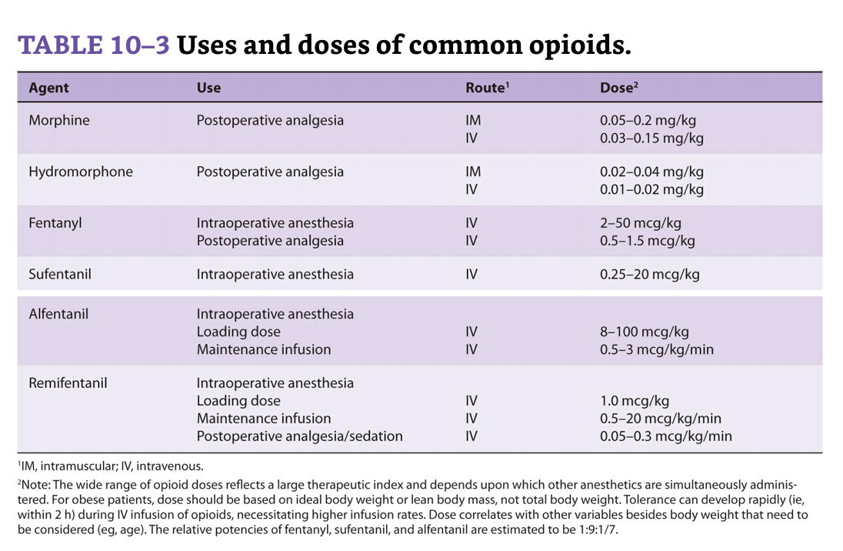
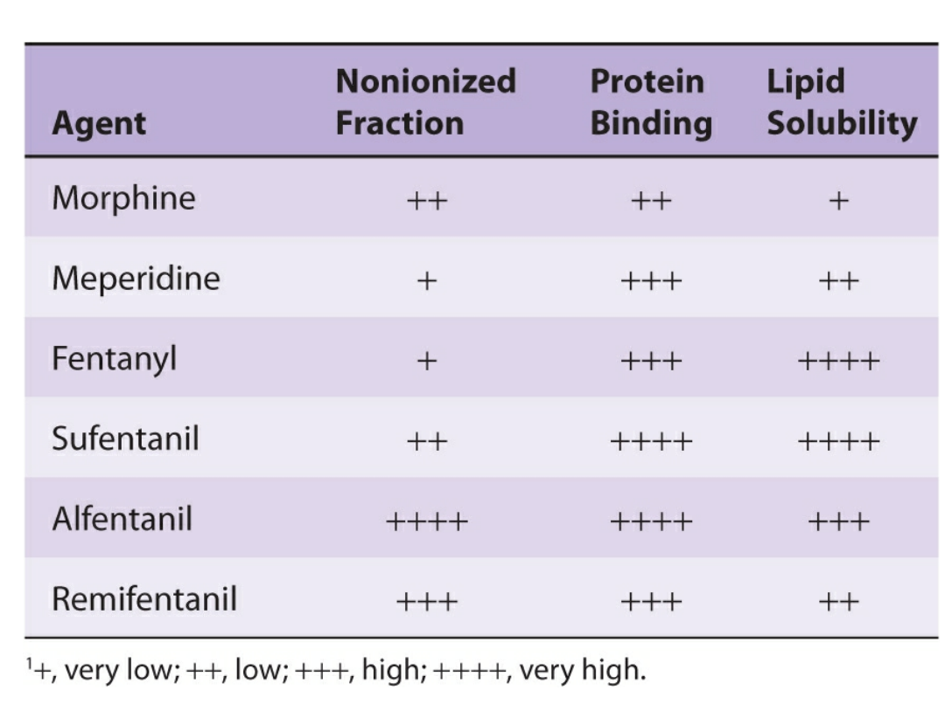

- Antisialogogues (dry up secretions):

  - Atropine
    - Physical Structure: Atropine is a tertiary amine. The naturally occurring levorotatory form is active, but the commercial mixture is racemic
    - Dosage & Packaging: As a premedication, atropine is administered intravenously or intramuscularly in a range of 0.01–0.02 mg/kg, up to the usual adult dose of 0.4–0.6 mg. Larger intravenous doses up to 2 mg may be required to completely block the cardiac vagal nerves in treating severe bradycardia. Atropine sulfate is available in a multitude of concentrations.
    - Clinical Considerations: Atropine has particularly potent effects on the heart and bronchial smooth muscle and is the most efficacious anticholinergic for treating bradyarrhythmias. Patients with coronary artery disease may not tolerate the increased myocardial oxygen demand and decreased oxygen supply associated with the tachycardia caused by atropine. A derivative of atropine, ipratropium bromide, is available in a metered-dose inhaler for the treatment of bronchospasm. Its quaternary ammonium structure significantly limits systemic absorption. Ipratropium solution (0.5 mg in 2.5 mL) seems to be particularly effective in the treatment of acute chronic obstructive pulmonary disease when combined with a β-agonist drug (eg, albuterol). The central nervous system effects of atropine are minimal after the usual doses, even though this tertiary amine can rapidly cross the blood–brain barrier. Atropine has been associated with mild postoperative memory deficits, and toxic doses are usually associated with excitatory reactions. An intramuscular dose of 0.01–0.02 mg/kg reliably provides an antisialagogue effect. Atropine should be used cautiously in patients with narrow-angle glaucoma, prostatic hypertrophy, or bladder-neck obstruction.

  - Glycopyrolate
    - Physical Structure: Glycopyrrolate is a synthetic product that differs from atropine in being a quaternary amine and having both cyclopentane and a pyridine moieties in the compound.
    - Dosage & Packaging: The usual dose of glycopyrrolate is one-half that of atropine. For instance, the premedication dose is 0.005–0.01 mg/kg up to 0.2–0.3 mg in adults. Glycopyrrolate for injection is packaged as a solution of 0.2 mg/mL.
    - Clinical Considerations: Because of its quaternary structure, glycopyrrolate cannot cross the blood–brain barrier and is almost devoid of central nervous system and ophthalmic activity. Potent inhibition of salivary gland and respiratory tract secretions is the primary rationale for using glycopyrrolate as a premedication. Heart rate usually increases after intravenous—but not intramuscular—administration. Glycopyrrolate has a longer duration of action than atropine (2–4 h vs 30 min after intravenous administration).

  - Scopolamine
    - Physical Structure: Scopolamine, a tertiary amine, differs from atropine by the addition of an epoxide to the heterocyclic ring.
    - Dosage & Packaging: The premedication dose of scopolamine is the same as that of atropine, and it is usually given intramuscularly. Scopolamine hydrobromide is available as solutions containing 0.3, 0.4, and 1 mg/mL.
    - Clinical Considerations: Scopolamine is a more potent antisialagogue than atropine and causes greater central nervous system effects. Clinical dosages usually result in drowsiness and amnesia, although restlessness, dizziness, and delirium are possible. The sedative effects may be desirable for premedication but can interfere with awakening following short procedures. Scopolamine has the added virtue of preventing motion sickness. The lipid solubility allows transdermal absorption, and transdermal scopolamine has been used to prevent postoperative nausea and vomiting. Because of its pronounced ocular effects, scopolamine is best avoided in patients with closed-angle glaucoma.

- What is the BIS monitoring system?
  - Raw EEG data, collected by electrodes placed on the forehead and temporal regions, are processed by the computer module to create a dimensionless numeric representation of the degree of cortical activity and thus the level of sedation. Lower numbers correspond to greater depths of hypnosis. One common format is the bispectral index (BIS). A BIS goal of 40 to 60 usually indicates adequate hypnosis. The ASA Task Force suggests that brain electrical activity monitoring is not routinely indicated but should be considered on an individualized basis for selected patients (high-risk patients, light general anesthesia).

- What is Train of Four (TOF)?
  - TOF stimulation consists of four successive supramaximal stimuli delivered at 2 Hz, no less than 10 seconds apart (figure 5). After administration of a nondepolarizing NMBA, responses at this frequency show fade, or progressively decreasing amplitude of the responses (figure 6). A TOF ratio (TOFR) is calculated by dividing the amplitude of the fourth response by the amplitude of the first response, and requires an objective measure of the response to stimulation.
  - With progressive nondepolarizing block, the fourth twitch disappears, followed by the third, then the second, and finally the first (figure 7). As neuromuscular block dissipates, the train-of-four twitches reappear one by one, with the degree of fade decreasing as full neuromuscular function returns. The TOF count (TOFC) is defined as the number of detectable evoked responses, and it correlates with the degree of neuromuscular block, as follows [17]:
  - ●TOFC = 1 : >95 percent of nicotinic acetylcholine receptors (nAChRs) blocked
  - ●TOFC = 2 : 85 to 90 percent of nAChRs blocked
  - ●TOFC = 3 : 80 to 85 percent of nAChRs blocked
  - ●TOFC = 4 : 70 to 75 percent of nAChRs blocked

- Explain the oxyhemoglobin dissociation curve
  - It is a curve that describes the relationship between oxygen tension and binding (percentage oxygen saturation of hemoglobin) (Figure 21-3). Efficient oxygen transport relies on the ability of hemoglobin to reversibly load and unload oxygen. The sigmoid shape of the curve facilitates unloading of oxygen in the peripheral tissues, where the PaO2 is low. At the capillary level, a large amount of oxygen is released from the hemoglobin, resulting in a relatively small drop in tension. This allows an adequate gradient for diffusion of oxygen into the cells and limits the degree of hemoglobin desaturation. The curve may be shifted to the left or right by many variables
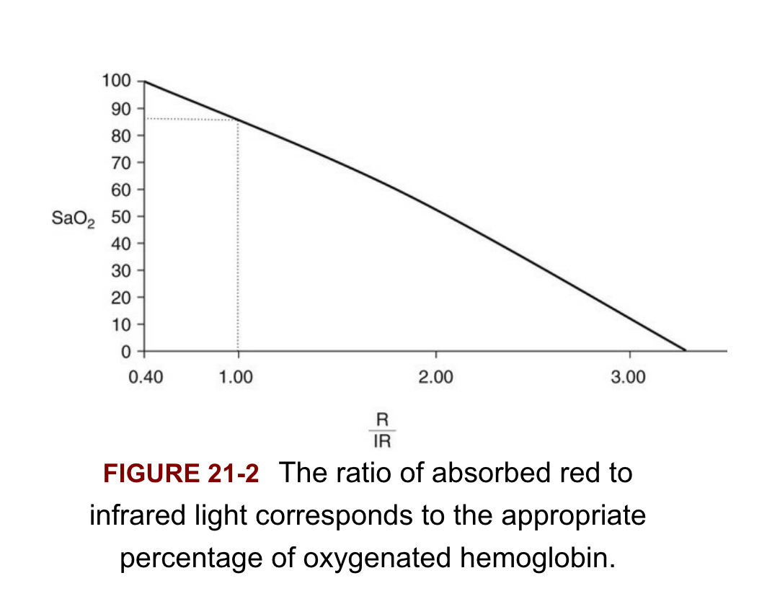

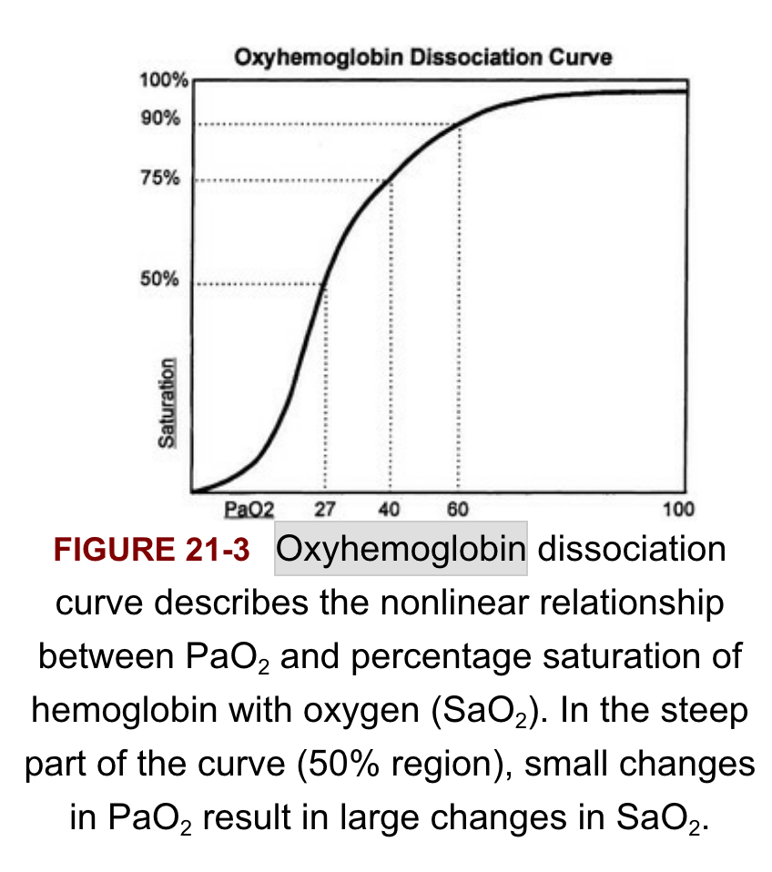
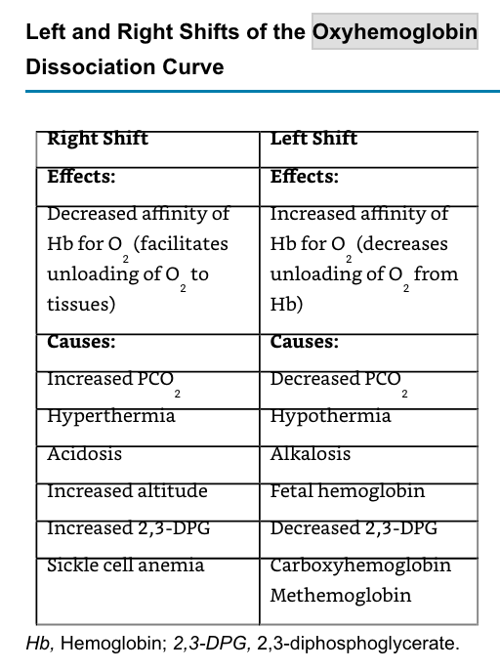

- Explain the nitric oxide cycle.
  - NO is a small molecule produced by vascular endothelium. Formed from the action of NO synthetase on arginine, NO crosses into vascular smooth muscle and stimulates guanylate cyclase. Subsequently cGMP produces smooth muscle relaxation and vasodilation.
  - NO is administered by inhalation and crosses the alveolar membrane to the vascular endothelium, producing smooth muscle relaxation. But when it crosses into the circulation, it is rapidly bound to hemoglobin (with an affinity 1500 times greater than carbon monoxide) and deactivated; thus it has no systemic vasodilator effect. Since it is only delivered to ventilated alveoli, it increases blood to those areas and improves V/Q matching.

- Spinal Cord Injuries
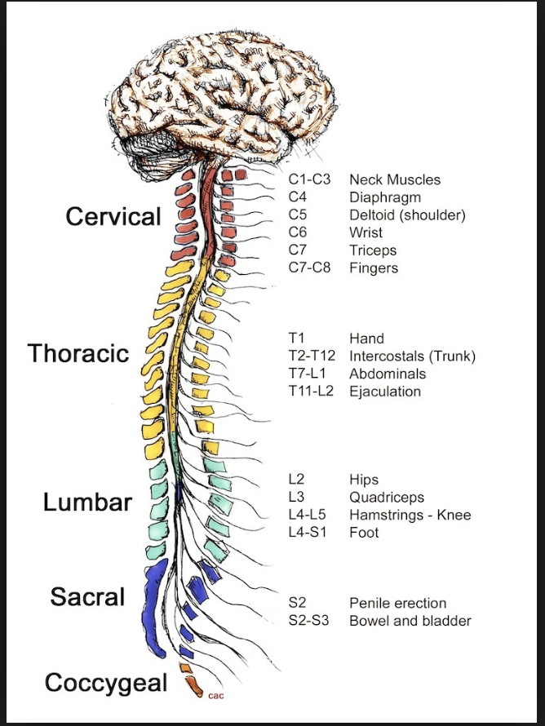
  - Neuro
o LOC, GCS, RASS
o Traumatic Brain Injuries
▪ EDH epidural (between the dura mater and skull)
▪ SDH subdural (between the dura and the arachnoid mater)
▪ SAH subarachnoid (between the brain and arachnoid)
▪ IPH intraparenchymal (into the brain tissue)
▪ IVH intraventricular (into ventricular system where csf is produced and circulates through towards the subarachnoid space)

Trauma Scenarios
  - 23 y/o male presents to the emergency department post MVA with the following injuries:
    - Grade IV liver lac
    - Sternal fracture
    - Multiple right sided rib fractures
    - Prolonged extracation in 19 degree weather
    - GCS of 8 upon arrival
  - What would you, as the nurse, be worried about in this scenario?
    - GCS 8=intubate!
    - Prolonged extracation in cold weather could lead to hypothermia and in hypothermic patients, their thrombin production and platelet functions are impaired.
    - Trauma triad of death
      - Hypothermia
        - Hypothermia occurs when the body’s mechanisms for temperature regulation are overwhelmed. The brain’s hypothalamus produces hormones that influence a variety of bodily functions, including body temperature. Core body temperature normally ranges between 36.5–37.5°C. Hypothalamic control of temperature occurs through several mechanisms, including heat conservation with peripheral vasoconstriction and heat production through shivering, influenced by epinephrine. Heat production increases with muscle contractions and shivering. Some consider shivering one of the last resorts by which the body attempts to maintain temperature.
        - Hypothermia can impact any organ or system. It can also contribute to the development of acidosis due to decreased tissue perfusion, shivering and a decrease in the removal of lactic acid from the body.10–14 These events can lead to a decrease in oxygen utilization and an increase in carbon dioxide production.
        - When treating trauma patients, providers are encouraged to avoid unnecessarily or excessively exposing them to cooler environments, such as cold air, rain or snow, and provide a warmer environment if possible. Remove cold, wet clothing and replace it with dry blankets. These are simple yet important steps to support the patient’s body temperature. If possible, avoid infusing cold or cool intravenous fluids, as this can contribute to reducing body temperature. If allowed, active warming in the field may be initiated with caution. Overly aggressive rewarming can lead to pulmonary edema, reduced cough reflex and excessive bronchial secretions.

Acidosis
        - Acidosis is the result of excessive acid accumulation in body fluids. Causes include excessive acid in the blood, decreased clearance of acidic byproducts, loss of bicarbonate from the blood, buildup of carbon dioxide in the blood resulting from poor lung function, and slow breathing.
        - A normally healthy body maintains a balance of hydrogen ions (acids) through buffers. This involves the interaction of acids, bases and the proper pH level. The pH level is a measure of acidity rated on a scale of 0–14. Values less than 7.0 are considered acidic; those above 7.0 are basic . Normal pH of the blood is between 7.35–7.45.
        - Recall that the buffer system includes plasma proteins, hemoglobin in red blood cells, sodium bicarbonate (NaHCO3) and carbonic acid (H2CO3). The renal (kidneys) and pulmonary (lungs) systems are also important in maintaining homeostasis. A change in one component can influence any other.
        - Lactic acidosis develops when metabolism occurs in the setting of low oxygen, resulting in the accumulation of lactic acid. Respiratory acidosis develops when there’s excessive carbon dioxide, which can be caused by a decreased ability to remove carbon dioxide through effective breathing.
        - Metabolic acidosis can be caused by several different pathways. In metabolic acidosis, the lungs and kidneys try to compensate. If the acidosis continues, the body’s pH buffering system can be overwhelmed. This can result in lowered blood pH, triggering stimulation of the central nervous system, resulting in tachypnea. Tachypnea can increase the amount of carbon dioxide exhaled. The renal system may compensate by excreting more acid in the urine. Both mechanisms can be overwhelmed if the body continues to produce too much acid, leading to severe acidosis and eventually, if not reversed, death.

Coagulopathies
        - Coagulopathies, or bleeding disorders, can result from a number of different events, including excessive fluid dilution, metabolic events (e.g., acidosis), hypothermia and disseminated intravascular coagulation (DIC).
        - When a healthy person is injured, proteins in the blood become activated and travel to the site of injury to assist with clotting. In normal situations the clotting factors are replaced as they are consumed. In DIC widespread thrombus formation occurs, along with depletion of platelets and clotting factors. This leads to clotting complications, clot breakdowns and an inflammatory response by the body. As a result, small blood clots begin to form in the blood vessels; these can occlude vessels and cut off blood supply to organs. As this cycle continues, clotting factors are consumed, and simultaneous hemorrhage and thrombosis can occur. The systemic activation of the coagulation process leads to depletion of coagulation factors as clots are formed and broken down.

  - What is the organ most affected in blunt trauma and what are the grades?
    - The liver is the organ affected the most in blunt trauma
      - Grade I Liver Laceration
        - Hematomas: subcapsular and nonexpanding
        - Lacerations: <1 cm parenchymal depth and nonbleeding
      - Grade II Liver Laceration
        - Hematomas: 10-50% of subcapsular surface <1 cm intraparenchymal hematoma
        - Lacerations: Capsular tear with active bleeding; 1-3 cm in length
      - Grade III Liver Laceration
        - Hematomas: >50% surface area or actively bleeding; ruptured or parenchymal hematoma; hematoma >10 cm or expanding
        - Lacerations: >3 cm deep into parenchyma
      - Grade IV Liver Laceration
        - Ruptured parenchymal hematomas with active bleeding or parenchymal disruption involving 25-75% of a hepatic lobe
      - Grade V Liver Laceration
        - Parenchymal disruption involving >75% of hepatic lobe
        - Vascular injury involving retrohepatic cava or juxtahepatic venous injury.
      - Grade VI Liver Laceration
        - Hepatic avulsion with avulsion of vascular structures
    - So in this patient with a grade IV liver laceration, you would worry about the patient bleeding.
    - Give PRBCs! Fluids in this situation, such as LR or NS, would not be useful because the patient is losing blood. Crystalloids may actually be detrimental in this situation because you are diluting the blood that the patient still has. Administration of fluid boluses leads to hemodilution, fewer circulating RBCs to carry hemoglobin, worsening acidosis (due to anaerobic metabolism), dilution of coagulation factors, increased inflammatory response (due to large volumes of crystalloids)

  - Thoracic skeletal fractures and associated injuries:
    - Sternal fractures -> Blunt cardiac injury
    - First and second rib fractures -> great vessel injuries, brachial plexus injuries, head and spinal cord injuries
    - Multiple rib fractures and flail chest -> pulmonary contusion, pneumothorax, hemothorax
    - Lower rib fractures (7-12) -> liver (right-sided injuries), spleen (left-sided injuries)

  - This patient has multiple right sided rib fractures. What are potential complications from this and what interventions should be implemented to solve them?
    - With any displaced rib fracture, lung contusions or lacerations are possible.
    - Other possibilities: tension pneumothorax, simple pneumothorax, hemothorax.
    - If this patient had left sided rib fractures, then we would be more worried about a ruptured diaphragm. The reasoning being the right hemidiaphragm is protected by the solid mass of the liver.
    - In the case that the patient is exhibiting symptoms of a tension pneumothorax, immediate decompression is indicated.
      - Needle thoracentesis: A 14-gauge needle is inserted into the second intercostal space, midclavicular line. After this, prepare for chest tube placement as the definitive treatment.
      - Chest tube insertion: Inserted at the fifth intercostal space, at the anterior or midaxillary line.

  - This patient has a sternal fracture. What would you be worried about?
    - Blunt cardiac injury, which includes myocardial contusion and, less commonly, injury to the ventricular septum, coronary arteries or cardiac valves.
      - Potential complication: Cardiac Tamponade
        - Collection of blood in the pericardial sac, even as little as 50 ml. This decreases SV and cardiac output.
        - Findings: Beck’s Triad= hypotension, distended neck veins, muffled heart tones
        - Prepare for pericardial decompression: A 3 to 4 cm incision is made just to the left of the xiphoid process. Needle pericardiocentesis may also be used to relieve the symptoms, but is only a temporary solution.

  - Let’s say this patient is hypotensive from the liver laceration because of the internal bleeding. What intervention should be implemented or what medication would you use and why?
    - In this case, blood products are what the patient needs because of the bleeding caused by the liver laceration. This patient will obviously need surgery, but temporarily to help with the hemorrhagic shock, the patient needs to be transfused.
    - Packed red blood cells — The mainstay of therapy for patients with intravascular volume depletion due to bleeding is the replacement of volume loss with blood products, typically packed red blood cells. Patients may receive fluid replacement, usually with crystalloid (eg, isotonic saline), while waiting for blood products to be delivered to the bedside. The management of patients with hemorrhagic shock is discussed separately.
    - With severe hypotension, a vasopressor or inotrope (dopamine or epinephrine) may be necessary to increase arterial blood pressure until the intravascular volume deficit is at least partially corrected.
    - Why would you use dopamine or epinephrine rather than other vasopressors?
      - In this situation, we are looking for a temporary fix. We need to stop the bleeding, but even with PRBC’s the patients blood pressure is still tanking.
      - Dopamine: When used in moderate doses (3–10 mcg/kg/min), β1-stimulation increases myocardial contractility, heart rate, systolic blood pressure, and cardiac output. Myocardial oxygen demand typically increases more than supply.
      - Epinephrine: An endogenous catecholamine synthesized in the adrenal medulla. Direct stimulation of a-1 receptors of the myocardium by epinephrine raises blood pressure, cardiac output, and myocardial oxygen demand by increasing contractility and heart rate (increased rate of spontaneous phase of IV depolarization). A-1 stimulation decreases splanchnic and renal blood flow but increases coronary perfusion pressure by increasing aortic diastolic pressure. Systolic blood pressure rises, although B2-mediated vasodilation in skeletal muscle may lower diastolic pressure. B2-stimulation also relaxes bronchial smooth muscle.

  - What medications would help with hypotension in the patient with cardiac tamponade?
    - + Inotrope such as dobutamine to increase cardiac contractility
      - Dobutamine is a racemic mixture of two isomers with affinity for both β1 and β2 receptors, with relatively higher selectivity for β1 receptors. Its primary cardiovascular effect is a rise in cardiac output as a result of increased myocardial contractility. A decline in peripheral vascular resistance caused by β2-activation activation usually prevents much of a rise in arterial blood pressure. Left ventricular filling pressure decreases, whereas coronary blood flow increases.

  - What is massive transfusion protocol (MTP)?
    - One part red blood cells to one part thawed plasma to one part platelets (1:1:1)
    - Shows less incidence of mortality in the actively bleeding trauma patient.
    - A concern with MTP is hypocalcemia because citrate is added.
    - Because calcium is a vital part of the clotting cascade, hypocalcemia as a result of MTP can actually worsen hypovolemic shock.

  - In the case of intubation in this patient, what would you consider?
    - Because of the high risk of hyperkalemia in this patient (already at high risk due to hemorrhagic shock, multiple fractures, and metabolic acidosis), succinylcholine should be avoided.
    - RSI medications to use:
      - Rocuronium would be a better option here, along with etomidate because of the minimal effects it has on the cardiovascular system.

- Different Types of Shock
  - Hypovolemic Shock:
    - Etiology: Hemorrhage, burns
    - Underlying Pathology: Whole blood loss, plasma loss

  - Obstructive Shock:
    - Etiology: Cardiac tamponade, tension pneumothorax, tension hemothorax
    - Underlying Pathology: Compression of the heart with obstruction to atrial filling, mediastinal shift with obstruction to atrial filling, combination of compression of the heart and mediastinal shift

  - Cardiogenic Shock:
    - Etiology: Myocardial infarction, dysrhythmias, blunt cardiac trauma
    - Pathology: Loss of cardiac contractility, reduced cardiac output, loss of cardiac contractility and dysrhythmias
    - Medication Treatment:
      - Norepinephrine and dopamine are first line agents.

  - Distributive Shock:
    - Etiology:
      - Neurogenic Shock: Loss of vasomotor tone due to decreases in sympathetic control.
        - Medication Treatment: Norepinephrine is a sympathomimetic that increases heart rate and cardiac output by working both as an alpha and a Beta-1 agonist, and is the first line agent for neurogenic shock. Dopamine also vasoconstricts the peripheral circulation and increases heart rate and is considered a second line agent. Phenylephrine, an alpha adrenergic receptor agonist will help vasoconstrict the peripheral vasculature in cases without bradycardia
      - Anaphylactic Shock: Vasodilation due to immune reaction to allergens (release if histamine)
      - Septic Shock: Mediated by systemic inflammatory response syndrome (SIRS) with hypotension and perfusion abnormalities.
        - Norepinephrine is the first line agent with both vasoconstrictive properties and inotropic support. Vasopressin may be added, a potent vasoconstrictor, it raises systemic vascular resistance and enhances water reabsorption from the kidney.

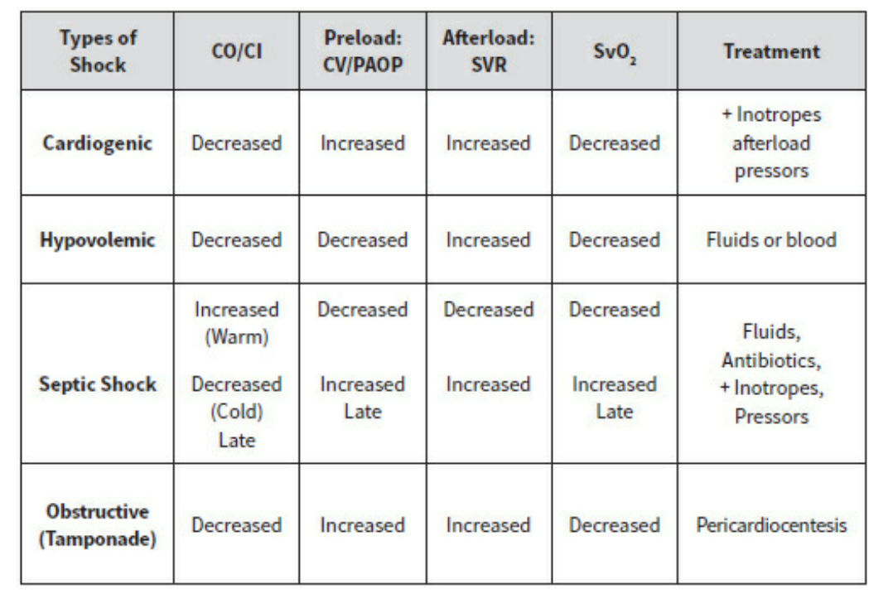
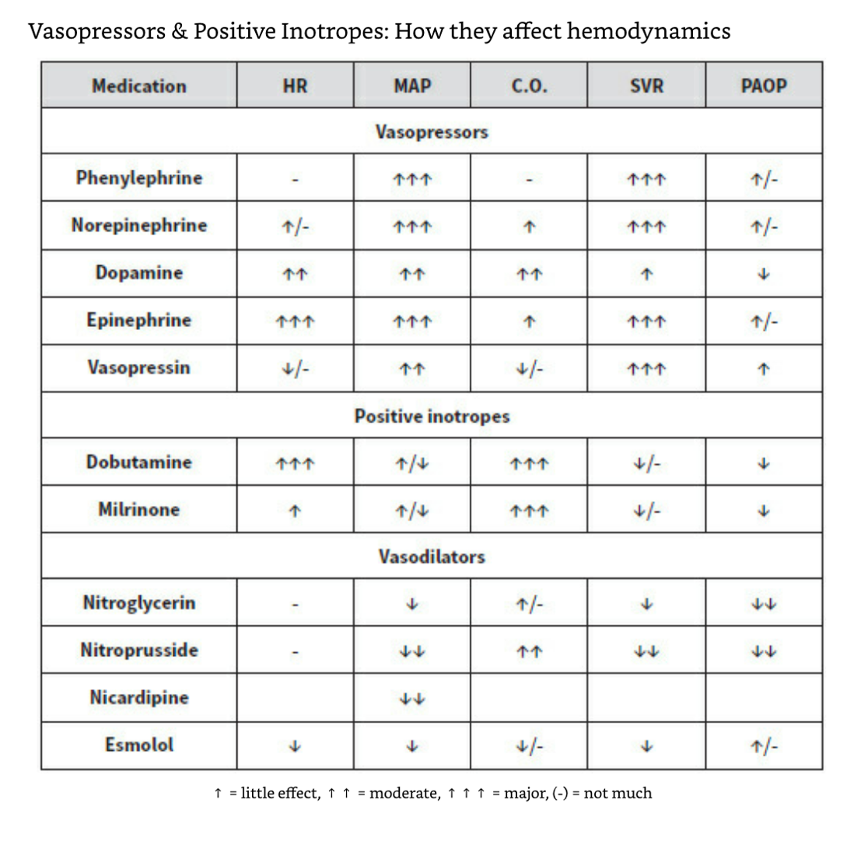

- Different transfusion types and their indications for use

  - Packed red blood cells:
    - Red blood cell transfusions are used to treat hemorrhage and to improve oxygen delivery to tissues. Transfusion of red blood cells should be based on the patient's clinical condition. Indications for transfusion include symptomatic anemia (causing shortness of breath, dizziness, congestive heart failure, and decreased exercise tolerance), acute sickle cell crisis, and acute blood loss of more than 30 percent of blood volume.
  - Fresh Frozen Plasma:
    - Fresh frozen plasma (FFP) contains all plasma proteins, including most clotting factors. Transfusions of FFP are indicated in the treatment of isolated factor deficiencies, the reversal of warfarin therapy, and the correction of coagulopathy associated with liver disease. Each unit of FFP generally increases the level of each clotting factor by 2–3% in adults. The initial therapeutic dose is usually 10–15 mL/kg. The goal is to achieve 30% of the normal coagulation factor concentration. FFP may also be used in patients who have received massive blood transfusions (see below) and continue to bleed following platelet transfusions. Patients with antithrombin III deficiency or thrombotic thrombocytopenic purpura also benefit from FFP transfusions. Each unit of FFP carries the same infectious risk as a unit of whole blood. In addition, occasional patients may become sensitized to plasma proteins. ABO-compatible units should generally be given but are not mandatory. As with red cells, FFP should generally be warmed to 37°C prior to transfusion.
  - Platelets:
    - Platelet transfusions should be given to patients with thrombocytopenia or dysfunctional platelets in the presence of bleeding. Prophylactic platelet transfusions are also indicated in patients with platelet counts below 10,000–20,000 × 109/L because of an increased risk of spontaneous hemorrhage. Platelet counts less than 50,000 × 109/L are associated with increased blood loss during surgery. Thrombocytopenic patients often receive prophylactic platelet transfusions prior to surgery or invasive procedures. Vaginal delivery and minor surgical procedures may be performed in patients with normal platelet function and counts greater than 50,000 × 109/L. Administration of a single unit of platelets may be expected to increase the platelet count by 5000–10,000 × 109/L, and with administration of a platelet apheresis unit, by 30,000–60,000 × 109/L. ABO-compatible platelet transfusions are desirable but not necessary. Transfused platelets generally survive only 1–7 days following transfusion. ABO compatibility may increase platelet survival. Rh sensitization can occur in Rh-negative recipients due to the presence of a few red cells in Rh-positive platelet units. Moreover, anti-A or anti-B antibodies in the 70 mL of plasma in each platelet unit can cause a hemolytic reaction against the recipient’s red cells when a large number of ABO-incompatible platelet units is given. Administration of Rh immunoglobulin to Rh-negative individuals can protect against Rh sensitization following Rh-positive platelet transfusions.

- Complications of Blood Transfusion

  - IMMUNE COMPLICATIONS
    - Immune complications following blood transfusions are primarily due to sensitization of the recipient to donor red cells, white cells, platelets, or plasma proteins. Less commonly, the transfused cells or serum may mount an immune response against the recipient.
  - Hemolytic Reactions:
    - Hemolytic reactions usually involve specific destruction of the transfused red cells by the recipient’s antibodies. Less commonly, hemolysis of a recipient’s red cells occurs as a result of transfusion of red cell antibodies. Incompatible units of platelet concentrates, FFP, clotting factor concentrates, or cryoprecipitate may contain small amounts of plasma with anti-A or anti-B (or both) alloantibodies. Transfusions of large volumes of such units can lead to intravascular hemolysis. Hemolytic reactions are commonly classified as either acute (intravascular) or delayed (extravascular).
  - Acute Hemolytic Reactions:
    - Acute intravascular hemolysis is usually due to ABO blood incompatibility, and the reported frequency is approximately 1:38,000 transfusions. The most common cause is misidentification of a patient, blood specimen, or transfusion unit. These reactions are often severe, and may occur after infusion of as little as 10–15 mL of ABO-incompatible blood. The risk of a fatal hemolytic reaction is about 1 in 100,000 transfusions. In awake patients, symptoms include chills, fever, nausea, and chest and flank pain. In anesthetized patients, an acute hemolytic reaction may be manifested by a rise in temperature, unexplained tachycardia, hypotension, hemoglobinuria, and diffuse oozing in the surgical field. Disseminated intravascular coagulation, shock, and kidney failure can develop rapidly. The severity of a reaction often depends upon the volume of incompatible blood that has been administered.
  - Management of hemolytic reactions can be summarized as follows:
    - 1. If a hemolytic reaction is suspected, the transfusion should be stopped immediately and the blood bank should be notified.
    - 2. The unit should be rechecked against the blood slip and the patient’s identity bracelet.
    - 3. Blood should be drawn to identify hemoglobin in plasma, to repeat compatibility testing, and to obtain coagulation studies and a platelet count.
    - 4. A urinary catheter should be inserted, and the urine should be checked for hemoglobin.
    - 5. Osmotic diuresis should be initiated with mannitol and intravenous fluids.
  - Delayed Hemolytic Reactions:
    - A delayed hemolytic reaction—also called extravascular hemolysis—is generally mild and is caused by antibodies to non-D antigens of the Rh system or to foreign alleles in other systems such as the Kell, Duffy, or Kidd antigens. Following an ABO and Rh D-compatible transfusion, patients have a 1–1.6% chance of forming antibodies directed against foreign antigens in these other systems. By the time significant amounts of these antibodies have formed (weeks to months), the transfused red cells have been cleared from the circulation. Moreover, the titer of these antibodies subsequently decreases and may become undetectable. Reexposure to the same foreign antigen during a subsequent red cell transfusion, however, triggers an anamnestic antibody response against the foreign antigen. The hemolytic reaction is therefore typically delayed 2–21 days after transfusion, and symptoms are generally mild, consisting of malaise, jaundice, and fever. The patient’s hematocrit typically fails to rise, or rises only transiently, in spite of the transfusion and the absence of bleeding. The serum unconjugated bilirubin increases as a result of hemoglobin breakdown.
    - Diagnosis of delayed antibody-mediated hemolytic reactions may be facilitated by the antiglobulin (Coombs) test. The direct Coombs test detects the presence of antibodies on the membrane of red cells. In this setting, however, this test cannot distinguish between recipient antibodies coated on donor red cells and donor antibodies coated on recipient red cells. The latter requires a more detailed reexamination of pretransfusion specimens from both the patient and the donor.
    - The treatment of delayed hemolytic reactions is primarily supportive. The frequency of delayed hemolytic transfusion reactions is estimated to be approximately 1:12,000 transfusions. Pregnancy (exposure to fetal red cells) can also be responsible for the formation of alloantibodies to red cells.
  - Nonhemolytic Immune Reactions:
    - Nonhemolytic immune reactions are due to sensitization of the recipient to the donor’s white cells, platelets, or plasma proteins; the risk of these reactions may be minimized by the use of leukoreduced blood products.
    - Febrile Reactions:
      - White cell or platelet sensitization is typically manifested as a febrile reaction. Such reactions are relatively common (1–3% of transfusion episodes) and are characterized by an increase in temperature without evidence of hemolysis. Patients with a history of repeated febrile reactions should receive leukoreduced transfusions only.
    - Urticarial Reactions:
      - Urticarial reactions are usually characterized by erythema, hives, and itching without fever. They are relatively common (1% of transfusions) and are thought to be due to sensitization of the patient to transfused plasma proteins. Urticarial reactions can be treated with antihistaminic drugs (H1 and perhaps H2 blockers) and steroids.
    - Anaphylactic Reactions:
      - Anaphylactic reactions are rare (approximately 1:150,000 transfusions). These severe reactions may occur after only a few milliliters of blood has been given, typically in IgA-deficient patients with anti-IgA antibodies who receive IgA-containing blood transfusions. The prevalence of IgA deficiency is estimated to be 1:600–800 in the general population. Such reactions require treatment with epinephrine, fluids, corticosteroids, and H1 and H2 blockers. Patients with IgA deficiency should receive thoroughly washed packed red cells, deglycerolized frozen red cells, or IgA-free blood units.
    - Transfusion-Related Acute Lung Injury:
      - Transfusion-related acute lung injury (TRALI) presents as acute hypoxia and noncardiac pulmonary edema occurring within 6 h of blood product transfusion. It may occur as frequently as 1:5000 transfused units, and with transfusion of any blood component, but especially platelets and FFP. It is thought that transfusion of antileukocytic or anti-HLA antibodies results in damage to the alveolar–capillary membrane. Treatment is similar to that for acute respiratory distress syndrome (see Chapter 57), with the important difference that TRALI may resolve within a few days with supportive therapy.
    - Graft-Versus-Host Disease:
      - This type of reaction may be seen in immunocom-promised patients. Cellular blood products contain lymphocytes capable of mounting an immune response against the compromised (recipient) host. Use of special leukocyte filters alone does not reliably prevent graft-versus-host disease; irradiation (1500–3000 cGy) of red cell, granulocyte, and platelet transfusions effectively eliminates lymphocytes without altering the efficacy of such transfusions.
    - Post-Transfusion Purpura:
      - Rarely, profound thrombocytopenia may occur following blood transfusions. This post-transfusion purpura results from the development of platelet alloantibodies. For unknown reasons, these antibodies also destroy the patient’s own platelets. The platelet count typically drops precipitously 5–10 days following transfusion. Treatment includes intravenous IgG and plasmapheresis.
    - Transfusion-Related Immunomodulation:
      - Allogeneic transfusion of blood products may diminish immunoresponsiveness and promote inflammation. Post-transfusion immunosuppression is clearly evident in renal transplant recipients, in whom preoperative blood transfusion improves graft survival. Recent studies suggest that perioperative transfusion may increase the risk of postoperative bacterial infection, cancer recurrence, and mortality, all of which emphasize the need to avoid unnecessary administration of blood products.

- Coagulation, blood thinning agents, and what to do in emergencies

  - What does PTT measure?
    - PTT measures the clotting ability of all factors in the intrinsic and common pathways except factor XIII. Partial thromboplastin is substituted for platelet phospholipid and eliminates platelet variability. Normal PTT is about 40 to 100 seconds; >120 seconds is abnormal.
  - Describe INR
    - The international normalized ratio (INR) was introduced to improve the consistency of oral anticoagulant therapy. INR is calculated as (PTpatient/PTnormal-ISI), where ISI is the international sensitivity index assigned to the test system. The recommended therapeutic ranges for standard oral anticoagulant therapy and high-dose therapy, respectively, are INR values of 2 to 3 and 2.5 to 3.5.
  - Describe aPTT
    - Maximal activation of the contact factors (XII and XI) eliminates the lengthy natural contact activation phase and results in more consistent and reproducible results. An activator is added to the test tube before addition of partial thromboplastin. Normal aPTT is 25 to 35 seconds.
  - How is ACT measured?
    - Fresh whole blood (providing platelet phospholipid) is added to a test tube already containing an activator. The automated ACT is widely used to monitor heparin therapy in the operating room. The normal range is 90 to 120 seconds.
  - What is the prothrombin time?
    - Prothrombin time (PT) measures the extrinsic and common pathways. Tissue thromboplastin is added to the patient's plasma. The test varies in sensitivity and response to oral anticoagulant therapy whether measured as PT in seconds or simple PT ratio (PTpatient/PTnormal), where “normal” is the mean normal PT value of the laboratory test system. Normal PT is 10 to 12 seconds.
  - Heparin
    - A polyanionic mucopolysaccharide that accelerates the interaction between antithrombin III and the activated forms of factors II, X, XI, XII, and XIII, effectively neutralizing each. The half-life of heparin's anticoagulant effect is about 90 minutes in a normothermic patient. Patients with reduced levels of antithrombin III are resistant to the effect of heparin. Heparin may also affect platelet function and number through an immunologically mediated mechanism.
    - APTT routinely checked
    - Reversal: Protamine sulfate
    - Heparin-Induced Thrombocytopenia
      - Platelet count drops by ≥ 50% within 5 – 10 days of exposure to heparin » May develop more quickly if previous exposure to heparin » Erythematous lesions around SQ Heparin injection sites » 25% of patients develop systemic reaction
      - Fever • Chills • Tachypnea • Tachycardia • Generally not associated with bleeding »
      - **Major Complication: Thrombosis
      - Treatment
        - D/C all forms of Heparin.
        - Meds: Angiomax, Argatroban

  - Warfarin
    - A vitamin K antagonist and is used to prevent thrombosis and emboli. A patient on warfarin is at high risk for intraoperative bleeding. Before stopping a patient's warfarin, it is important to know the indication for anticoagulation, the type and urgency of the surgery, and the consequences of intraoperative bleeding. Patients who are at very high risk of thromboembolism but nonetheless need to discontinue their anticoagulant (e.g., warfarin) in the perioperative setting are often bridged with low-molecular-weight heparin, another much shorter-acting anticoagulant. Because warfarin has such a long half-life (about 2.5 days) and heparin has such a short half-life (about 1.5 hours), a patient may be instructed to stop warfarin 4 days before surgery and then, often as an inpatient, undergo regular heparin injections up until a few hours before surgery. Once the surgery is completed (and depending on the postoperative bleeding risk), the warfarin can be restarted.
    - PT/INR routinely checked
    - Reversal: Vitamin K (phytonadione)

Respiratory and Pulmonary Physiology

- What are some causes of hypoxemia?
  - Hypoventilation:
    - Patients under general anesthesia may be incapable of maintaining an adequate minute ventilation, due to muscle relaxants or the ventilatory depressant effects of anesthetic agents. Hypoventilation is a common problem postoperatively, but an adequate oxygenation saturation may be confirmed by pulse oximetry. Worsening hypercarbia from hypoventilation can be masked by increasing the inspired oxygen concentration. Always deliver the least amount of oxygen necessary and evaluate the patient if oxygen saturation is inadequate.
  - Shunt:
    - Sepsis, liver failure, arteriovenous malformations, pulmonary emboli, and right-to-left cardiac shunts may create sufficient shunting to result in hypoxemia. As shunted blood is not exposed to alveoli, hypoxemia caused by a shunt cannot be overcome by increasing FiO2.
  - Ventilation-perfusion (V/Q) mismatch:
    - Ventilation and perfusion of the alveoli in the lung ideally have close to a 1-to-1 relationship, promoting efficient oxygen exchange between alveoli and blood. When alveolar ventilation and perfusion to the lungs are unequal (V/Q mismatching), hypoxemia results. Causes of V/Q mismatching include atelectasis, lateral decubitus positioning, bronchial intubation, bronchospasm, pneumonia, mucus plugging, pulmonary contusion, and adult respiratory distress syndrome. Hypoxemia due to V/Q mismatching can usually be overcome by increasing FiO2.
  - Diffusion defects:
    - Efficient O2 exchange depends on a healthy interface between the alveoli and the bloodstream. Advanced pulmonary disease and pulmonary edema may have associated diffusion impairment.
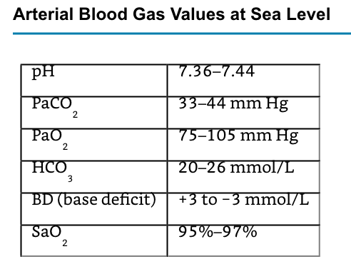
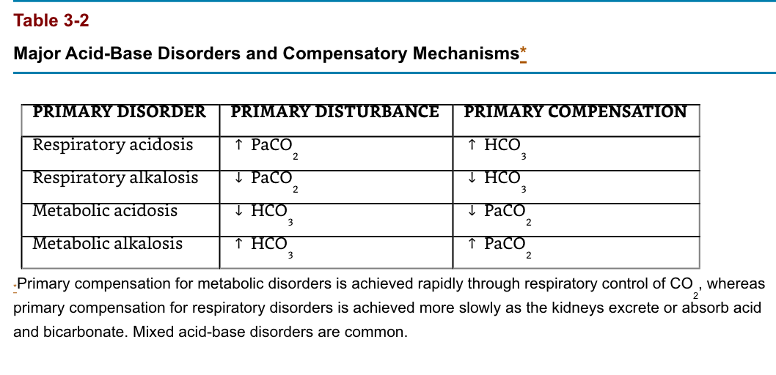

- What are the different ventilatory modes?

  - Continuous Mandatory Ventilation (CMV)
    - In this mode, the ventilator cycles from expiration to inspiration after a fixed time interval. The interval determines the ventilatory rate. Typical settings on this mode provide a fixed VT and fixed rate (and, therefore, minute ventilation) regardless of patient effort, because the patient cannot breathe spontaneously. Settings to limit inspiratory pressure guard against pulmonary barotrauma, and indeed CMV can be provided in a pressure-limited (rather than volume-limited) way. Controlled ventilation is best reserved for patients capable of little or no ventilatory effort. Awake patients with active ventilatory effort require sedation, possibly with muscle paralysis.

  - Assist-Control (AC) Ventilation
    - Incorporation of a pressure sensor in the breathing circuit of AC ventilators permits the patient’s inspiratory effort to be used to trigger inspiration. A sensitivity control allows selection of the inspiratory effort required. The ventilator can be set for a fixed ventilatory rate, but each patient effort of sufficient magnitude will trigger the set VT. If spontaneous inspiratory efforts are not detected, the machine functions as if in the control mode. Most often, AC ventilation is used in a volume-limited format, but it can also be provided in a pressure-limited way

  - Intermittent Mandatory Ventilation (IMV)
    - IMV allows spontaneous ventilation while the patient is on the ventilator. A selected number of mechanical breaths (with fixed VT) is given to supplement spontaneous breathing. At high mandatory rates (10–12 breaths/min), IMV essentially provides all of the patient’s ventilation; at low rates (1–2 breaths/min), it provides minimal mechanical ventilation and allows the patient to breathe relatively independently. The VT and frequency of spontaneous breaths are determined by the patient’s ventilatory drive and muscle strength. The IMV rate can be adjusted to maintain a desired minute ventilation. IMV has found greatest use as a weaning technique.

  - Synchronized intermittent mandatory ventilation (SIMV)
    - Times the mechanical breath, whenever possible, to coincide with the beginning of a spontaneous effort. Proper synchronization prevents superimposing (stacking) a mechanical breath in the middle of a spontaneous breath, resulting in a very large VT. As with CMV and AC, settings to limit inspiratory pressure guard against pulmonary barotrauma. The advantages of SIMV include patient comfort, and if used for weaning, the machine breaths provide a backup if the patient becomes fatigued. However, if the rate is too low (4 breaths/ min), the backup may be too low, particularly for weak patients who may not be able to overcome the added work of breathing during spontaneous breaths.

  - IMV circuits
    - Provide a continuous supply of gas flow for spontaneous ventilation between mechanical breaths. Modern ventilators incorporate SIMV into their design, but older models must be modified by a parallel circuit, a continuous flow system, or a demand flow valve. Regardless of the system, proper functioning of one-way valves and sufficient gas flow are necessary to prevent an increase in the patient’s work of breathing, particularly when PEEP is also used. The IMV discussion has considered this to be a volume-limited format; however, it can also be provided in pressure-limited format if desired (see below).

  - Mandatory Minute Ventilation (MMV)
    - With MMV, the patient is able to breathe spontaneously (with pressure support) and also receive SIMV mechanical breaths, while the machine monitors the exhaled minute ventilation. In this mode, the machine continuously adjusts the number of SIMV mechanical breaths so that the sum total of spontaneous and mechanical ventilation equals the desired set minute ventilation. The role of this mode in weaning remains to be defined.

  - Pressure Support Ventilation (PSV)
    - Pressure support ventilation was designed to augment the VT of spontaneously breathing patients and overcome any increased inspiratory resistance from the tracheal tube, breathing circuit (tubing, connectors, and humidifier), and ventilator (pneumatic circuitry and valves). Microprocessor-controlled machines have this mode, which delivers sufficient gas flow with every inspiratory effort to maintain a predetermined positive pressure throughout inspiration. When inspiratory flow decreases to a predetermined level, the ventilator’s feedback (servo) loop cycles the machine into the expiratory phase, and airway pressure returns to baseline (Figure 57–2). The only setting in this mode is inspiratory pressure. The patient determines the respiratory rate and VT varies according to inspiratory gas flow, lung mechanics, and the patient’s own inspiratory effort. Low levels of PSV (5–10 cm H2O) are usually sufficient to overcome any added resistance imposed by the breathing apparatus. Higher levels (10–40 cm H2O) can function as a standalone ventilatory mode if the patient has sufficient spontaneous ventilatory drive and stable lung mechanics. The principal advantages of PSV are its ability to augment spontaneous VT, decrease the work of breathing, and increase patient comfort. However, if the patient fatigues or lung mechanics change, VT may be inadequate, and there is no backup rate if the patient’s intrinsic respiratory rate decreases or the patient becomes apneic. Pressure support is often used in conjunction with IMV (Figure 57–3). The IMV machine breaths provide backup, and a low level of pressure support is used to offset the increased work of breathing resulting from the breathing circuit and machine.

  - Pressure Control Ventilation (PCV)
    - Pressure control ventilation is similar to PSV in that peak airway pressure is controlled but is different in that a mandatory rate and inspiratory time are selected. As with pressure support, gas flow ceases when the pressure level is reached; however, the ventilator does not cycle to expiration until the preset inspiration time has elapsed. PCV may be used in both the AC and IMV modes. In AC, all breaths (either machine initiated or patient initiated) are time cycled and pressure limited. In IMV, machine-initiated breaths are time cycled and pressure limited. The patient may breathe spontaneously between the set rate, and the VT of the spontaneous breaths is determined by the patient’s pulmonary muscle strength. The advantage of PCV is that by limiting inspiratory pressure, the risks of barotrauma and volutrauma may be decreased. Also, by extending inspiratory time, better mixing and recruitment of collapsed or flooded alveoli may be achieved, provided adequate PEEP levels are used.

  - Inverse I:E Ratio Ventilation (IRV)
    - IRV reverses the normal inspiratory:expiratory time ratio of 1:3 or greater to a ratio of greater than 1:1. This may be achieved by adding an end-inspiratory pause, by decreasing peak inspiratory flow during volume-cycled ventilation (CMV), or by setting an inspiratory time such that inspiration is longer than expiration during PCV (PC-IRV). Intrinsic PEEP may be produced during IRV and is caused by air trapping or incomplete emptying of the lung to the baseline pressure prior to the initiation of the next breath. This air trapping increases FRC until a new equilibrium is reached. This mode does not allow spontaneous breathing and requires heavy sedation or neuromuscular blockade. IRV with PEEP is effective for improving oxygenation in patients with decreased FRC.

  - Airway Pressure Release Ventilation (APRV)
    - APRV or bilevel ventilation is a mode in which a relatively high PEEP is used, despite the patient being allowed to breathe spontaneously. Intermittently, the PEEP level decreases to help augment the elimination of CO2 (Figure 57–4). The inspiratory and expiratory times, high and low PEEP levels, and spontaneous respiratory activity determine minute ventilation. Initial settings include a minimum PEEP of 10–12 cm H2O and a release level of 5–10 cm H2O. Advantages of APRV appear to be less circulatory depression and pulmonary barotrauma as well as less need for sedation. This technique appears to be an attractive alternative to PC-IRV for overcoming problems with high peak inspiratory pressures in patients with reduced lung compliance.

  - High-Frequency Ventilation (HFV)
    - Three forms of HFV are available. High-frequency positive-pressure ventilation involves delivering a small “conventional” VT at a rate of 60–120 breaths/ min. High-frequency jet ventilation (HFJV) utilizes a small cannula at or in the airway through which a pulsed jet of high-pressure gas is delivered at a set frequency of 120–600 times/min (2–10 Hz). The jet of gas may entrain air (Bernoulli effect), which may augment VT. High-frequency oscillation employs a driver (usually a piston) that creates to-and-fro gas movement in the airway at rates of 180–3000 times/min (3–50 Hz).

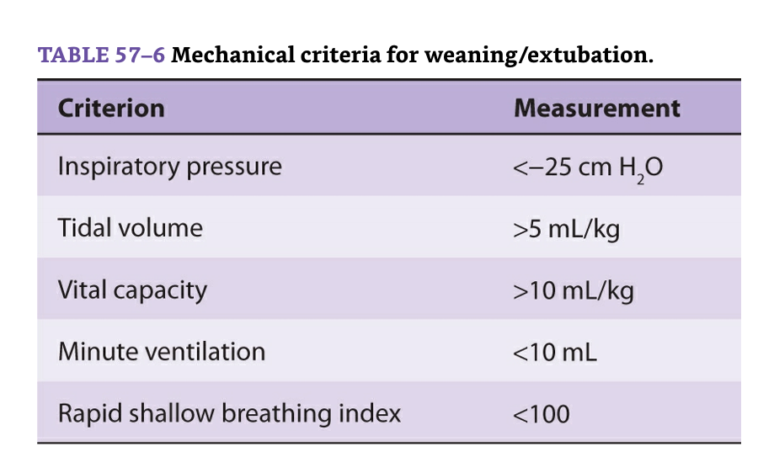

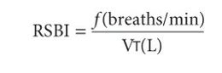
  - Patients with an RSBI <100 can successfully be extubated

- POSITIVE AIRWAY PRESSURE THERAPY
  - Positive airway pressure therapy can be used in patients who are breathing spontaneously as well as those who are mechanically ventilated. The principal indication for positive airway pressure therapy is a decrease in FRC resulting in absolute or relative hypoxemia. By increasing transpulmonary distending pressure, positive airway pressure therapy can increase FRC, improve (increase) lung compliance, and reverse ventilation/perfusion mismatching. Improvement in the latter parameter will show as a decrease in venous admixture and an improvement in arterial O2 tension.

  - Positive End-Expiratory Pressure:
    - Application of positive pressure during expiration as an adjunct to a mechanically delivered breath is referred to as PEEP. The ventilator’s PEEP valve provides a pressure threshold that allows expiratory flow to occur only when airway pressure exceeds the selected PEEP level.

  - Continuous Positive Airway Pressure:
    - Application of a positive-pressure threshold during both inspiration and expiration with spontaneous breathing is referred to as CPAP. Constant levels of pressure can be attained only if a high-flow (inspiratory) gas source is provided. When the patient does not have an artificial airway, tightly fitting full-face masks, nasal masks, nasal “pillows” (ADAM circuit), or nasal prongs (neonatal) can be used. Because of the risks of gastric distention and regurgitation, CPAP masks should be used only on patients with intact airway reflexes and with CPAP levels less than 15 cm H2O (less than lower esophageal sphincter pressure in normal persons). Expiratory pressures above 15 cm H2O require an artificial airway.

  - CPAP versus PEEP
    - The distinction between PEEP and CPAP is often blurred in the clinical setting because patients may breathe with a combination of mechanical and spontaneous breaths. Therefore, the two terms are often used interchangeably. In the strictest sense, “pure” PEEP is provided as a ventilator-cycled breath. In contrast, a “pure” CPAP system provides only sufficient continuous or “on-demand” gas flows (60–90 L/min) to prevent inspiratory airway pressure from falling perceptibly below the expiratory level during spontaneous breaths (Figure 57–5). Some ventilators with demand valve–based CPAP systems may not be adequately responsive and result in increased inspiratory work of breathing. This situation can be corrected by adding low levels of (inspiratory) PSV if in a volume-targeted mode or changing to a pressure-targeted mode. In clinical practice, controlled ventilation, PSV, and CPAP/ PEEP support can be delivered by most modern ICU ventilators. Manufacturers have also developed specific devices to deliver bilevel inspiratory positive airway pressure (IPAP) with expiratory positive airway pressure (EPAP) in either a spontaneous or time-cycled fashion. The term bilevel positive airway pressure (BiPAP) has become a commonly used phrase, adding to the confusion of airway pressure terminology.

- Pulmonary Effects of PEEP & CPAP
  - The major effect of PEEP and CPAP on the lungs is to increase FRC. In patients with decreased lung volume, appropriate levels of either PEEP or CPAP will increase FRC and tidal ventilation above closing capacity, will improve lung compliance, and will correct ventilation/perfusion abnormalities. The resulting decrease in intrapulmonary shunting improves arterial oxygenation. The principal mechanism of action for both PEEP and CPAP appears to be expansion of partially collapsed alveoli. Recruitment (reexpansion) of collapsed alveoli occurs at PEEP or CPAP levels above the inflection point, defined as the pressure level on a pressure–volume curve at which collapsed alveoli are recruited (open); with small changes in pressure there are large changes in volume (Figure 57–6). Although neither PEEP nor CPAP decreases total extravascular lung water, studies suggest that they do redistribute extravascular lung water from the interstitial space between alveoli and endothelial cells toward peribronchial and perihilar areas. Both effects can potentially improve arterial oxygenation.
  - Excessive PEEP or CPAP, however, can overdistend alveoli (and bronchi), increasing dead space ventilation and reducing lung compliance; both effects can significantly increase the work of breathing. By compressing alveolar capillaries, overdistention of normal alveoli can also increase pulmonary vascular resistance and right ventricular afterload.
  - A higher incidence of pulmonary barotrauma is observed with excessive PEEP or CPAP, particularly at levels greater than 20 cm H2O. Disruption of alveoli allows air to track interstitially along bronchi into the mediastinum (pneumomediastinum). From the mediastinum, air can then rupture into the pleural space (pneumothorax) or the pericardium (pneumopericardium) or can dissect along tissue planes subcutaneously (subcutaneous emphysema) or into the abdomen (pneumoperitoneum or pneumoretroperitoneum). A bronchopleural fistula is the result of failure of an air leak to seal (close). Although barotrauma must be considered in any discussion of CPAP and PEEP, in fact, it may be more clearly associated with higher peak inspiratory pressures that result with increasing level of PEEP or CPAP. Other factors that may increase the risk of barotrauma include underlying lung disease, stacking of breaths (from too frequent breaths or too short expiratory times) so that intrinsic PEEP (dynamic hyperinflation or autoPEEP) develops, large VT (>10–15 mL/kg), and younger age.

- Hemodynamics and Cardiac:

  - Valvular auscultation points: »
    - Aortic valve: Right sternal border, 2nd ICS
    - Pulmonic valve: Left sternal border, 2nd ICS
    - Tricuspid valve: Left sternal border, 4 - 5th ICS
    - Mitral valve: Left mid-clavicular line, 5th ICS
  - Normal Heart Sounds »
    - S1: closure of the mitral & tricuspid valves • Loudest over mitral area, 5th ICS, Systole 1/3 of the cardiac cycle
    - S2: closure of pulmonic & aortic valve, Loudest over aortic area, 2nd ICS, Diastole, 2/3 of the cardiac cycle
  - Extra Heart Sounds »
    - S3 : Ventricular gallop, Auscultated in fluid overload; when preload is elevated, Normal in kids, high cardiac output, 3rd trimester of pregnancy, Listen over apex area • Sound is caused by a rapid rush of blood into a dilated, overfilled ventricle, Other causes: Cardiomyopathy, ventricular septal defect (VSD), mitral or tricuspid regurgitation
    - S4: Atrial gallop (pre-systolic), Sound caused by vibration of atria ejecting into non-compliant ventricles, Auscultated during ischemia (increased resistance to ventricular filling), Other causes: Ischemia, HTN, pulmonary stenosis, CAD, aortic stenosis, left ventricular hypertrophy, Listen over tricuspid or mitral area
- Cardiac Output ( CO ) = HR x SV (Stroke Volume)
  - normal SV 50-100 ml/beat
  - amount of blood pumped by ventricles each minute
  - 4-8 liters/minute
- Cardiac Index ( CI ) = CO/BSA (body surface area)
  - cardiac output adjusted accordingly to body size
  - 2.5 – 4.3 l/min
- CO Determined By
  - Heart Rate
  - Preload
  - Afterload
  - Contractility
  - Stroke Volume ( SV ) amt of blood ejected from each ventricle with each heartbeat
- SV = (CO x 1000) / HR
- Stroke Volume Index ( SVI) is stroke volume adjusted to body size
  - normal SVI = 25-45 mL/beat

