DRESSING CHANGES PART 1

SUTURE LINE

- Wash your hands
- Knock on the door
- Introduce yourself
- Verify two identifiers
- Explain what you will be doing, “Is that ok?”
- Are you in any pain? If yes, check to see when the last time administration of pain meds.
- Provide privacy
- Wash your hands
- Collect your materials
  - 4 gloves (2 pairs)
  - Red Bag
  - Mask (for your face)
  - Dressing tray
- Knock on door
- Place items on table
- Raise bed and lower bed rail
- Put on your Face Mask
- Put on your gloves
- Expose the section that you will be working with (Advise client what you will expose)
- Place red bag on the bed
  - Never place the red bag on the patient
  - Put far away that it won’t contaminate field
  - The red bag in your tray, trade with Hanna per her request

- Carefully remove the dressing and discard in red bag
- Look at the dressing
  - State “No drainage, if no drainage”
  - If drainage, note the Color, Odor, Consistency, Amount COCA
- “Edges are approximated”
- Touch around the wound…… “Does this hurt?” “Patient states he has no pain”
- Take off you gloves
NOTE: WE CAN LEAVE WOUND EXPOSED BECAUSE WE ARE STILL IN THE ROOM
- Lower bed, and lift side rails

- GO WASH HANDS
- Raise bed and lower side rail
- Look at the dressing tray
  - Verify that the tray has not expired. “Tray is not expired.”
  - “Tray is intact”, if unopened
- Open the tray
- Put on sterile gloves properly (hands should not be moved below our waist)
- Put barrier shiny side DOWN
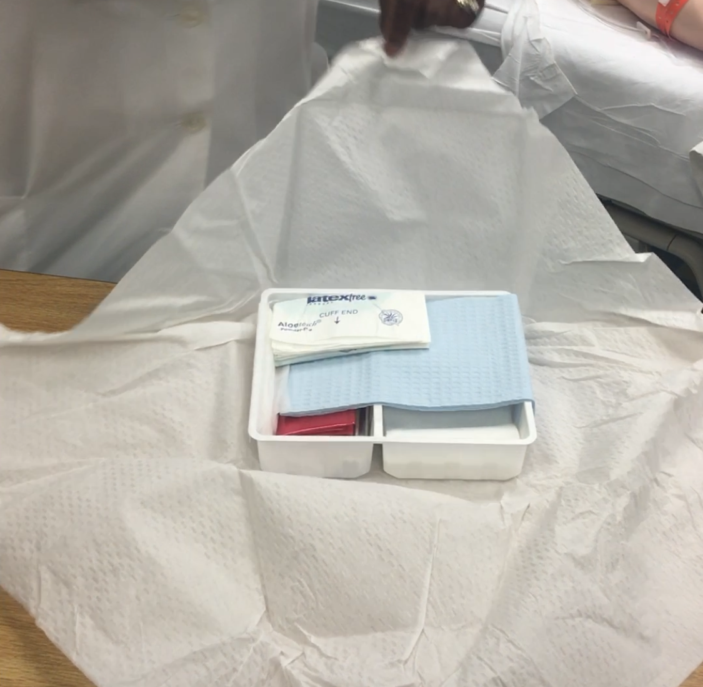
- Swabs can be used to measure wound by breaking the swabs away from patient and afterwards measuring with measuring tape
  - Across is width
  - Down is length
- Open iodine (saturated with Iodine, squeeze off a little in order to use)
  - Clean the center with one swab. DO NOT LIFT THE SWAB from TOP to BOTTOM
    - Discard in Red bag
  - Clean the side with another swab (same way)
    - Discard in Red bag
  - Clean other side the same way
    - Discard last swab in Red bag
- Take gauze, fold in 3 and place on the suture (never lift once placed)
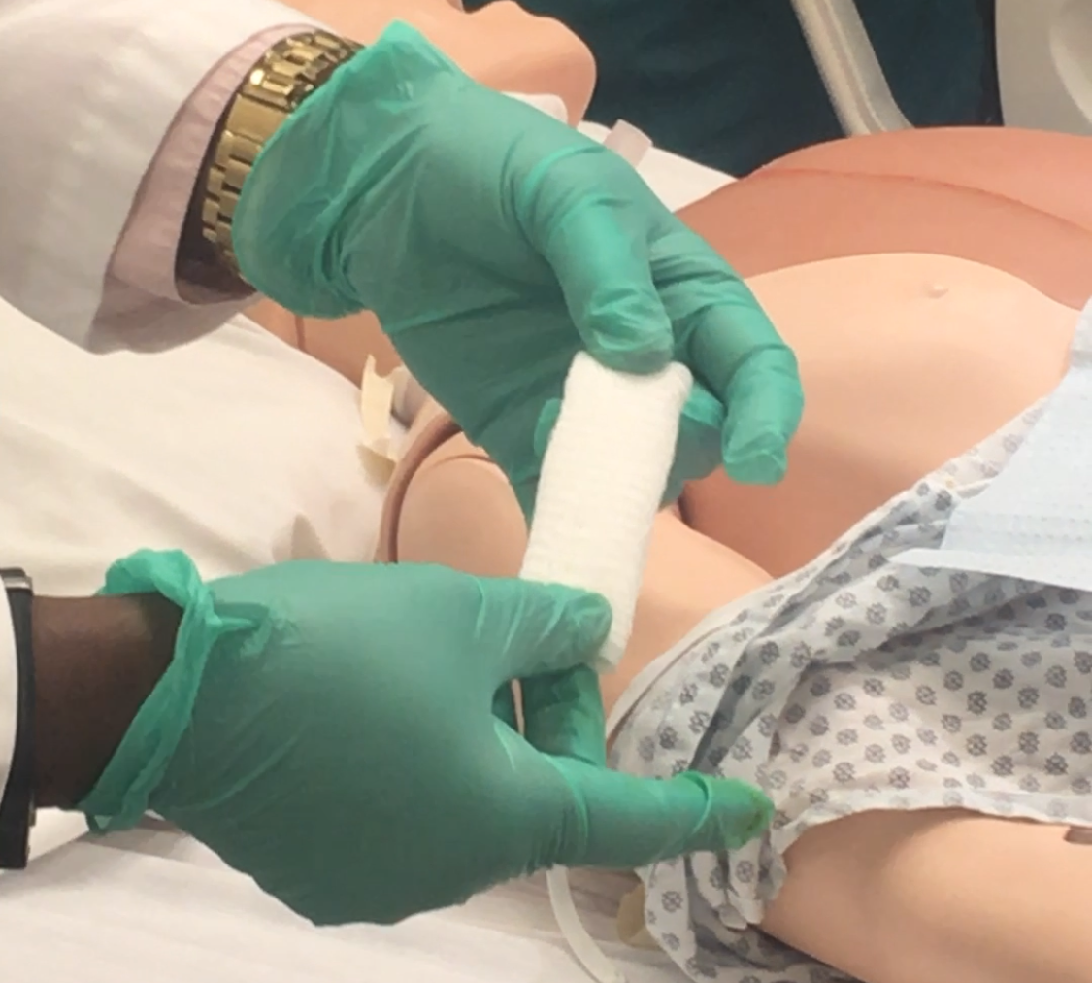
  - REPEAT until covered
- Discard barrier and discard
- Remove gloves and discard
- You can put new gloves on or continue without gloves since it is a clean wound (common sense!!!!) If you will be using gloves to apply tape make sure to pick up 3 pairs of gloves in the beginning
- Tape the wound (secure edges first and then the rest of the gauze)
- On a separate piece of tape write your initials and date (so you can know when the last dressing change was.

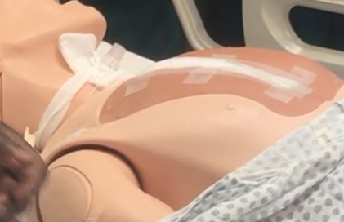
- Put on new gloves
- Cover the patient with their gown
- Raise bed and side rails
- Discard ALL the materials in garbage
- Scissors and Tweezers must be discarded in the sharps container
- Tie red bag and discard in biohazard
- Ask patient if there is anything else you can help them with
- Provide call light
- Exit room and wash hands

DRESSING CHANGES PART 2

WET TO DRY

- Wash your hands
- Knock on the door
- Introduce yourself
- Verify two identifiers
- Explain what you will be doing, “is that ok?”
- Are you in any pain? If yes, check to see when the last time administration of pain meds.
- Provide privacy
- Wash your hands
- Collect your materials
  - 4 gloves (2 pairs)
  - Red Bag
  - Mask (for your face)
  - Dressing tray
  - 0.9% Sodium Chloride (MAKE SURE YOU DON’T PICK UP STERILE WATER!!!!)
    - Check expiration.
    - “Sodium Chloride is not expired”
- Knock on door
- Place items on table
- Raise bed and lower bed rail
- Put on your Face Mask
- Put on your gloves
- Expose the section that you will be working with (Advise client what you will expose)
- Place red bag on the bed
  - Never place the red bag on the patient
  - Put far away that it won’t contaminate field
  - The red bag in your tray, trade with Hanna per her request
- Carefully remove the dressing and PACKING and discard in red bag
- Look at the dressing
  - State “No drainage, if no drainage”
  - If drainage, note the Color, Odor, Consistency, Amount COCA
- This will heal by SECONDARY INTENTION
  - Look at wound to confirm that it is nice and pink/red and granulating
  - “The edges are pink and granulating, no odor and no drainage”
- Take off you gloves
NOTE: WE CAN LEAVE WOUND EXPOSED BECAUSE WE ARE STILL IN THE ROOM
- Lower bed, and lift side rails

- GO WASH HANDS
- Raise bed and lower side rail
- Look at the dressing tray
  - Verify that the tray has not expired. “Tray is not expired.”
  - “Tray is intact”, if unopened
- Open the tray
- Put on sterile gloves properly (provided in tray)
  - hands should not be moved below our waist
- THROW IODINE IN RED BAG to not get tempted to use it
- Put barrier shiny side DOWN
- Swabs can be used to measure wound by breaking the swabs away from patient and afterwards measuring with measuring tape
  - Across is width
  - Down is length
  - And also measure the depth of wound (for other open wounds)
Note: measurements are not needed for surgical site

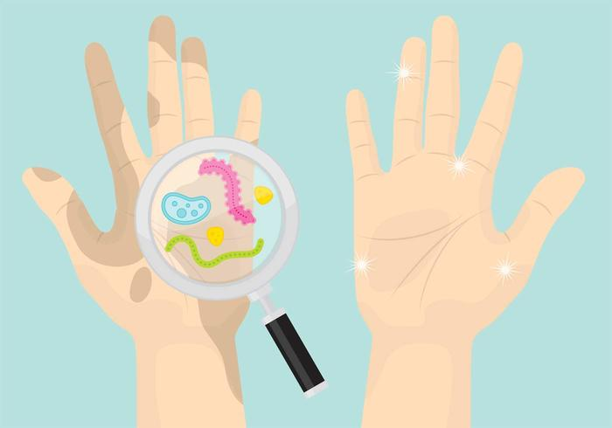 “CLEAN HAND DIRTY HAND”

- Advise Hanna which hand will be dirty and which hand will be clean
- Ask someone to pour saline in the compartment (hands of the pourer should be on saline label and high enough that hands will not touch tray)
- Clean wound with 3 pieces of gauze
  - Place gauze in saline, squeeze (leaving it damp not dry)
  - Transfer to other hand away from tray (not over the tray) so not contaminate
  - Clean from top to bottom and discard gauze and go back to get remaining gauze.
    - 1 gauze for inside
    - 1 gauze for one side (outside)
    - 1 gauze for other side (outside)
- Pack the wound (not to spill over the edges)
- Put on the abdominal pad with the stripe facing up
- You can put new gloves on or continue without gloves since it is a clean wound (common sense!!!!) If you will be using gloves to apply tape make sure to pick up 3 pairs of gloves in the beginning
- Tape the wound (window dressing)
- On a separate piece of tape write your initials and date (so you can know when the last dressing change was.
- Put on new gloves
- Cover the patient with their gown
- Raise bed and side rails
- Discard ALL the materials in garbage
- Scissors and Tweezers must be discarded in the sharps container
- Tie the red bag and discard in biohazard
- Ask patient if there is anything else you can help them with
- Provide call light
- Exit room and wash hands

DRESSING CHANGES PART 3

CENTRAL LINE (sits in the right atrium)

- Wash your hands
- Knock on the door
- Introduce yourself
- Verify two identifiers
- Explain what you will be doing, “is that ok?”
- Are you in any pain? If yes, check to see when the last time administration of pain meds.
- Provide privacy
- Wash your hands
- Collect your materials
  - 4 gloves (2 pairs)
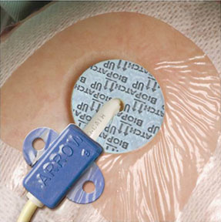
  - Red Bag
  - Mask (for your face)
  - Mask (for patients face)
  - CENTRAL Dressing tray
  - BIOPATCH (with blue or the other one shiny side up)

  - Chlorohexidine
  - Tegaderm bandage
- Knock on door
- Place items on table
- Raise bed and lower bed rail
- Put on your Face Mask
- Put the Face Mask on the patient
- Put on your gloves
- Expose the section that you will be working with (Advise client what you will expose)
- Place red bag on the bed
  - Never place the red bag on the patient
  - Put far away that it won’t contaminate field
  - The red bag in your tray, trade with Hanna per her request
- HOLD ON TO THE CENTRAL LINE while carefully removing the dressing and discard in red bag.
- Remove the circular Biopatch
- Assess insertion site, “The insertion site has no drainage, no redness, no odor”
  - If red, it is infected, advise doctor (DO NOT PULL OUT until we get another line ordered by physician)
- Take off you gloves
NOTE: WE CAN LEAVE WOUND EXPOSED BECAUSE WE ARE STILL IN THE ROOM
- Lower bed, and lift side rails

- GO WASH HANDS
- Raise bed and lower side rail
- Look at the dressing tray
  - Verify that the tray has not expired. “Tray is not expired.”
  - “Tray is intact”, if unopened
- Open the tray
- Put on sterile gloves properly (provided in tray)
  - hands should not be moved below our waist
- Put barrier shiny side DOWN
- Take the chlorohexidine, squeeze and allow chlorohexidine to accumulate in pad.
  - Start at insertion site, while holding the line, and scrub the hub.
  - Then, circle around the insertion site twice
- Place bio patch around the insertion site with the blue side (or shiny side up if you have the different bio patch)
- Remove your gloves and write your initials and date and time (the gauge if you put central line in) on the Tegaderm bandage.
  - Peel off the section that was written
  - Peel off the bandage and place on insertion site allowing the hub and insertion site to be visible.
  - While removing remaining pieces, continue to press on the bandage to secure edges.
  - Add the date to the bandage
- Cover the patient with their gown
- Raise bed and side rails
- Discard ALL the materials in garbage
- Scissors and Tweezers must be discarded in the sharps container
- Tie the red bag and discard in biohazard
- Ask patient if there is anything else you can help them with
- Provide call light
- Exit room and wash hands

