Head to Toe Final

- Wash Hands
- Knock on door
- Introduce yourself
- Verify name and date of birth
- “Mr/Mrs. ______ are you in any pain?” Assess for location, duration, radiation, alleviating factors, precipitating factors, quality and intensity. PQRST
  - Ask the patient if they are having any pain.
  - Where is the pain, how long has it lasted?
  - Does the pain travel anywhere?
  - What makes the pain feel better, what makes the pain worse?
  - Describe how the pain feels. Is it sharp, dull, pressure, stabbing?
  - On a scale of 1 to 10, with 10 being the worst pain you could possibly have
- Explain that you will be performing an assessment and explain to them that you will be placing your hands on them and to notify you if at any moment they feel uncomfortable.
- Wash hands
- Provide privacy
- Put on gloves
- Materials:
- Check BP, Temp, Pulse, Respirations, and weight (BMI 18.5 or less is underweight, >30 is obese)
- Raise bed and lower side rails
- Raise head of bed
- Mr/Mrs_______ can you tell me where we are?
- Do you know what Month we are in? Who is the President of the United States?
- Patient is Alert and Oriented x3.
- Patient has good hygiene and grooming.
- Patient is dressed appropriate.
- Patients Facial Expressions are _______
- Patients mood is appropriate and calm (calm, agitated, stressed, crying, flat affect, drowsy
- Patients speech is clear and not slurred.
- Patients posture is erect.
- , Patients body movements are smooth and controlled.
- Glascow Coma Number exceeds 15.
  - Eye Opening
    - Spontaneous (4 points)
    - To verbal command (3 points)
    - To pain (2 points)
    - None (1 point)
  - Best Motor Response
    - Obeys verbal command (6 points)
    - Localizes painful stimuli (5 points)
    - Flexion withdrawal from painful stimuli (4 points)
    - Decorticate response to painful stimuli (3 points)- is similar to normal withdrawal; however, as the arms flex at the elbows, the wrists also rotate in a spastic-type posture.

    - Decerebrate response to painful stimuli (2 points) -when the arms extend at the elbow with inward rotation
    - None (1 point)
  - Best Verbal Response
    - Oriented conversation (5 points)
    - Disoriented conversation (4 points)
    - Inappropriate words (3 points)
    - Incomprehensible words (3 points)
    - Incomprehensible sounds (2 points)
    - None (1 point)
- I am going to give you three words and I will ask you to repeat them in a few minutes. Car Walk Sky
- How are you feeling today?
- Have you had any thoughts of hurting yourself or others? Do you have a plan? How long have you been feeling this way?
- Assess skin:
  - Patients skin is consistent with their genetic background.
  - Temperature is normal
  - Patient has no diaphoresis.
  - Patients skin if smooth
  - Patient has no lesions
- Assess Head
  - Patients head is Norma cephalic and symmetrical
  - There are no lesions, masses, parasites or ova
- Facial features are symmetrical
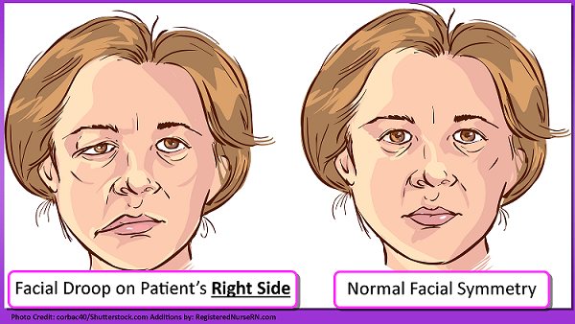
- Access Eyes (PERRLA)
  - There is no swelling of the eyelids.
  - Pupils are 3-5 mm in size
  - Shine Light in pupils
    - “Pupils are round and reactive to light accommodation”
    - Direct and Consensual Light reflex detected
  - Test for the 6 cardinal fields of sight
    - Cranial Nerve 3 (Ocularmotor)
    - 4 (Trochlear)
  - 6 (Abducens)
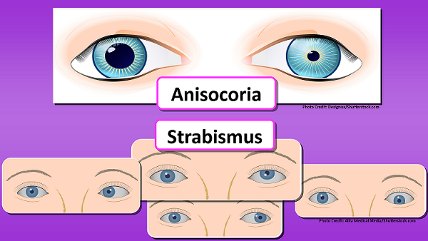
  - Extra-Ocular Muscle Movement

  - Inspects eyelashes are distributed evenly
  - Sclera is white
  - Conjunctiva is pink
  - There is no discharge or redness
- Assess Hearing
  - Have you had any difficulty hearing?
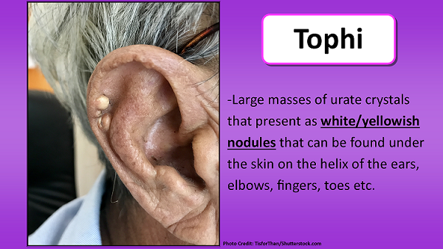
  - Inspects auricle and auditory meatus for appearance
  - There is no drainage (use penlight)
  - Palpate the pinna, tragus & mastoid for tenderness.
    - Do you feel any pain or discomfort?
    - Patient reports no tenderness

- Can you repeat the 3 words I asked you to remember in the beginning on the assessment?
  - Car, Walk, Sky
  - Patients recent memory intact
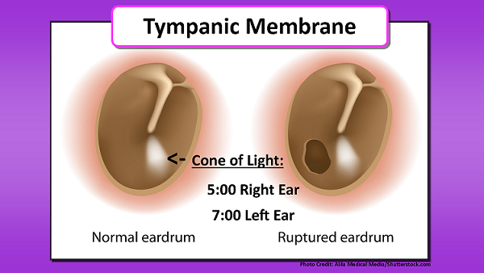
- Inspects nose
  - The nose is symmetry,
  - There is no septum deviation
  - There is no drainage.
  - Test for Patency. “Nostrils are patent.”
- Lips are not cracked and appear moist with no lesions.
- Oral mucosa is moist and pink.
- No teeth are missing/Teeth are missing.
  - Do you have difficulty chewing?
  - Do you have difficulty swallowing?
  - Do you wear dentures?
  - Please stick out your tongue (hypoglossal nerve) Say Ah!!
  - The tongue does not have any lesions or blisters.
  - The uvula rises symmetrically (glossopharyngeal nerve)
  - If the patient can swallow with ease and has no hoarseness when talking, cranial nerve X is intact (vagus nerve)
- Neck Assessment
  - Inspects head movement (flex, hyperextend, rotate left, rotate right-accessory nerve)
  - The trachea is midline and symmetric.
  - The thyroid is nonpalpable. (note for nodules, tenderness or enlargement…normally can’t palpate it.)
  - Have patients neck at a 45 degree angle
  - Carotid artery is flat and no distention is present.
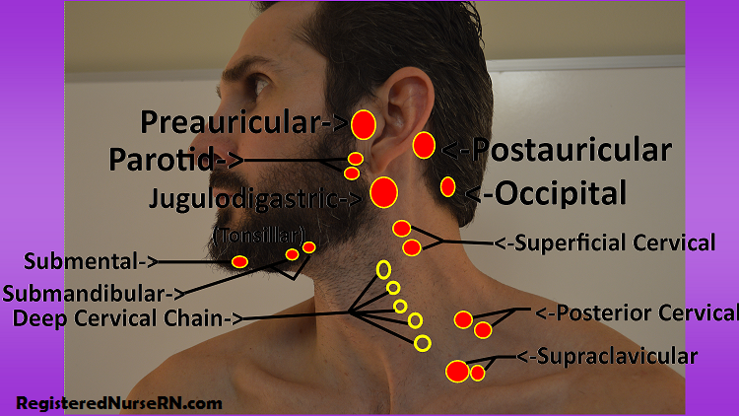
- Palpate for Carotid artery.
  - Auscultate for Bruits.
  - Bruits were not detected.
- Lungs
  - Assess turgor
    - Turgor is within 1-3 seconds
  - Inspect the chest. (anterior and posterior)
    - There are no lesions, no masses, no tenderness
    - No erythema, no pallor, no cyanosis
    - No crepitus detected
  - Percuss the chest (anteriorly and posteriorly)
  - Auscultate (anterior and posterior)
    - There are no adventitious sounds detected.
  - Chest is expanding symmetrically
  - The anterior-posterior diameter is 2:1
  - Patients breathing quality is normal, their pattern is at ease and unlabored.
  - Please repeat Blue Moon or 99. Vocal fremitus was detected bilaterally
  - There was no Palpates subcutaneous tissue for crepitus, masses, or tenderness.
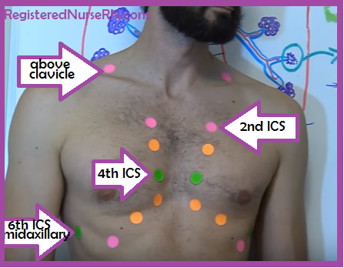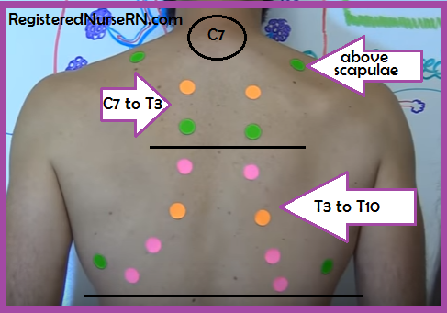
- Heart:
  - Palpates and Auscultate the five precordial points: aortic, pulmonic, tricuspid, erb's point, and mitral.
  - Palpate and Auscultate the Point of Maximum Impulse (PMI).
  - Use the Bell for S3 and S4
  - No thrills, or murmurs.
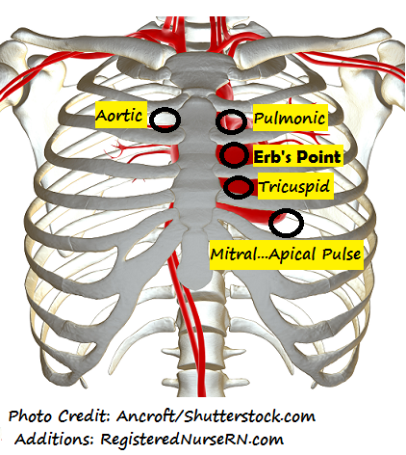
- Breasts:
  - Breasts are symmetric.
  - Have you noticed any dimpling in your breasts?
  - Palpate Supraclavicular and infraclavicular areas.
  - No tenderness or inflammation detected.
  - Teach breast self-examination
- Nails:
  - Fingernails are clean.
  - No clubbing present
  - Capillary refill is less than 3
- Assesses Upper Extremities:
  - No pallor, no cyanosis, no erythema
  - No scars, lesions or pigmentation
  - Temperature of extremities is warm and warmer as we approach the heart
  - Radial Pulse (0 = absent, 1 + = diminished, 2 ++ = expected, 3 +++ =bounding)
  - Hand strength - have patient grip two of your fingers at the same time.
    - Check for equality in strength. Never offer a patient your entire hand to grasp.
    - Bilateral strength
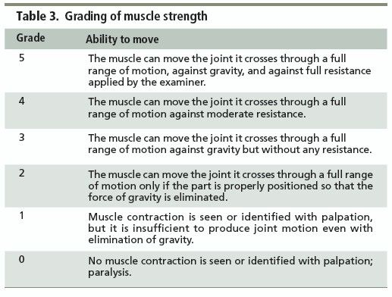
- Abdomen:
  - There are no scars, lesions, pigmentation.
  - Auscultate four quadrants of the abdomen using diaphragm (clockwise)
  - Bowel sounds are present, active and normal
  - Do you feel any pain or tenderness?
  - Begin to palpate for tenderness or masses.
  - Patient reports no pain or tenderness.
  - No masses detected.

- Assesses Lower Extremities skin:
  - No pallor, no cyanosis, no erythema
  - No scars, lesions or pigmentation
  - Hair is evenly distributed
  - Temperature of extremities is warm and warmer as we approach the heart
  - Dorsalis Pedis is amplitude (0 = absent, 1 + = diminished, 2 ++ = expected, 3 +++ =bounding)
  - Posterior Tibial is amplitude (0 = absent, 1 + = diminished, 2 ++ = expected, 3 +++ =bounding)
  - Assess for Homans Sign.
    - Do you have any pain in your calf?
  - No Edema is present.
  - The feet have no evidence of a DTI
  - The capillary refill is less than 3 seconds.
  - Leg strength - place your hands on the patient thighs. Have the patient push legs against the resistance of your hands. Check for equality in strength.
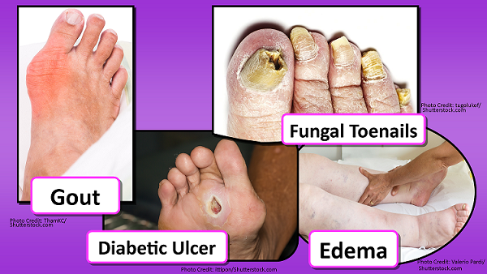
- Bowel movement
  - When was your last bowel movement?
  - Did you have any pain?
  - Was is black or red?
- Movement
  - Flex (forward)
  - Extend (backward)
  - Abduction (away)
  - Adduction (towards)
  - Internal rotation (hands behind your back)
  - External rotation (hands behind your head)
  - Circumduction (around in circle)
  - Elevation (shrug shoulders up)
  - Depression (shrug shoulders up)
  - “This is the Anatomical Position”

