HEENT, Eyes, Ears, Mouth, Neck
- Knock and introduce yourself
- Check two identifiers
- Explain what you are there to do.
- Verify if the patient is alert and oriented to time, place, and person

HEAD AND FACE
- Head is normcephalic
- All facial features are symmetrical
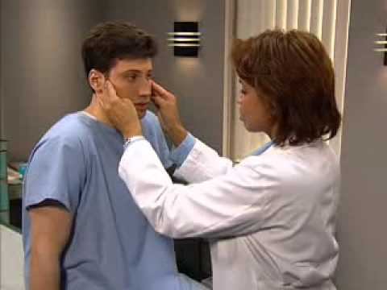
- No ovas (eggs), parasites
- No lesions or masses detected
- Temporal Artery is rated as +2, normal and symmetrical
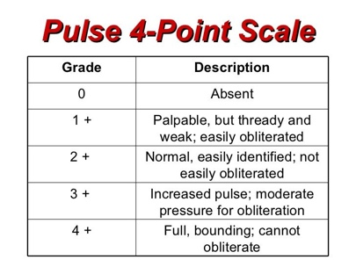
- Test the ROM of the temporomandibular joint
  - No crepitus detected.
  - Range of motion is normal
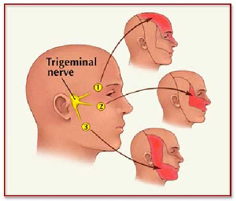
  - Any tenderness or pain?
- Assess trigeminal nerve CN V (5)
  - Use tongue depressor and break it as well to assess for pain sensation
  - Try to open your mouth against resistance
- Assess facial nerve CN VII (7)
  - Raise and lower your eyebrows
  - Please smile, frown
  - Please puff your cheeks
    - Examiner presses on cheeks
    - Air escapes cheeks bilaterally.
- “Cranial Nerve 5 and 7 are intact and symmetrical”.

Eyes and Visual Function
      - Use the Snellen chart.
        - Ask the patient to cover the eye and read the smallest letters they can see.
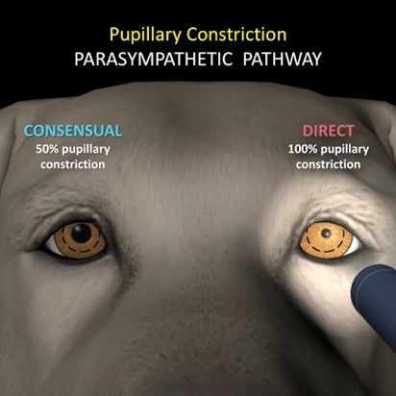
        - Cannot be more than 2 errors on a line (if one error on 20/20 you write 20/20-1)
      - Assess pupil (is it 3-5 mm which is normal)
      - Assess Direct and Consensual light reaction
      - Assess Accommodation
        - Pen light goes toward nose
        - Do the eyes and pupils accommodate?
      - Access Ocular movement
      - Assess Trochlear Nerve IV (4)
      - Assess Abducens Nerve VI (6)
      - Assess Oculomotor CN III (3)
      - Assess Eyelids (No swelling)
      - Assess Eyelashes (Eyelashes are evenly distributed)
      - Sclera (Confirm it is white)
      - Conjunctiva is pink and moist
      - Lacrimal Apparatus (there is no blockage)

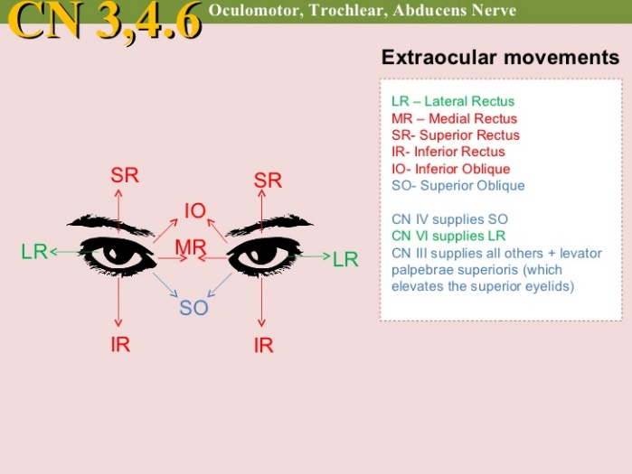

Hearing Acuity and Assessing Ear
- Assess auricle and meatus and mastoid process for appearance
  - Are ears proportional to body?
  - No cysts or polyps
- Is it tender?
- Is there any drainage?
- Assess landmarks correctly using otoscope.
  - Pull the ear (PINNA) up and back
  - Excess/Mild/Light cerum noted…. NO FOREIGN OBJECTS
- Perform the whisper test.
  - Stand behind patient and repeat letters and numbers
  - Patient should be covering other ear
  - “Cranial Nerve VIII (8) is in INTACT”
- Perform Rinne’s Test (tests Air and Bone conduction)
  - Explain to patient they will hear a buzzing and should advise when they stop hearing the buzzing. Bone conduction should be greater than Air conduction b/c BC bypasses problems in outer/middle ear
- Perform the Webber test
  - Ask the patient if he/she can hear equally
  - Place tuning fork BASE on top of head
  - The patient should be able to hear in the middle
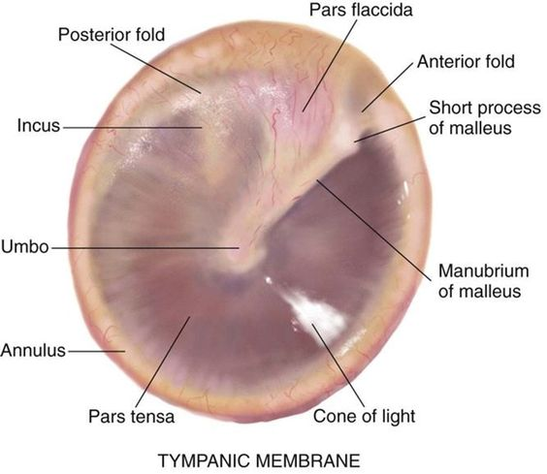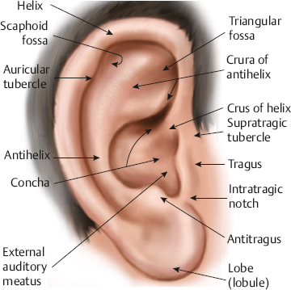

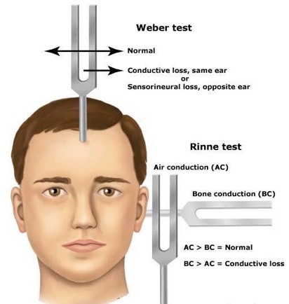

Nose and Sinus Assessment
- Advise the patient you will inspecting their nose
- “Please look up”
- Use the penlight and look up into the nose
  - Septum should be midline with no deviations
  - No drainage or polyps present
  - Hair is evenly distributed
- Confirm the nostrils are patent
  - Occlude one nostril and blow out
  - Repeat with the other nostril
  - Bilateral patency should be noted
- Test Olfactory nerve by closing one nostril and have patient smell coffee
  - Ask patient what they smell
  - Repeat with both nostrils
  - “Cranial Nerve I (Olfactory) is intact”
- Palpate sinuses for pain
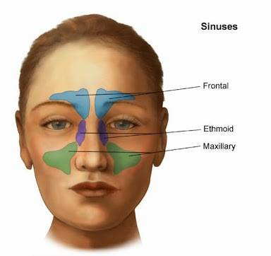

Mouth and Throat Assessment
- Lips have no cyanosis, are smooth, moist
- Smile
  - Teeth have no cracks
  - Teeth are white
- Inspect top and below the tongue for lesions
- Stick out your tongue and move side to side.
- Inspect the palate. Smooth and pink with no lesions
- Gums have no lesions and no bleeding is present
- No drainage noted
- Uvula rises symmetrically. Say “AHHHHHH” and is midline
- Inspect the throat for swelling, exudate, drainage.
- Rate the tonsils

Neck Assessment
- Advise the patient you will inspecting their neck
- Inspect the neck for lesions, masses or abrasions
- Inspect neck symmetry
- Ask patient to move neck
  - Chin to test
  - Turn head left to right
  - Touch ear to shoulder (without moving shoulders)
  - Hyperextend head
  - “Full range of motion noted”
- Inspect neck vessels for Jugular Distention (JVD). Patient should be looking to one side. “No jugular vein distention noted”
- Inspect position of trachea. “Trachea is midline”
- Inspect and palpate thyroid gland
- Palpate and auscultate carotid artery one side at a time.
  - Rate is between 60-100
  - Rhythm is regular
  - Intensity is normal
  - “Carotid arteries are both symmetrical”
- Auscultate for bruits using bell of stethoscope with light pressure.
  - “No bruits noted”
- Assess patient’s ability to shrug shoulders against resistance (CN XI -11)

Lymph Nodes
- Advise the patient you will inspecting their lymph nodes
- Palpate the lymph nodes
  - Lymph nodes should be movable and not firm.
    - Perauricular (before the ears)
    - Postauricular (almost on the mastoid process)
    - Occipital (back of your head, on the corners)
    - Tonsillar (almost at the carotid artery, above the jaw, closer to the back)
    - Submaxillary (under jaw bone)
    - Submental (under the chin, closer to the face)
    - Cervical (middle of the neck)
    - Supraclavicular (top of clavicle)
    - Infraclaviular (underneath calvicle)

Cranial Nerves: https://www.youtube.com/watch?v=sAFaTaavmO8

This Mnemonic is so outrageous and vulgar that it was the only one I was able to remember:

Oh, Oh, Oh, To Touch And Feel Virgin Girls Vagina And Hair
- Oh Olfactory Smell
- Oh Optic Vision
- Oh Occulomotor Controls Shape of Lens
- To Trochlear Moves eyeball
- Touch Trigeminal Mastication
- And Abducens Abducts eye (moves side to side)
- Feel Facial Facial Expressions
a
- Virgin Vestibulocochlear Balance and equilibrium
- Girls Glossopharyngeal Swallowing and taste buds
- Vagina Vagus Impulses to Larynx and Pharynx
and
- (Spinal) Turns head side to side via sternomastoid and trapezius
- Hair Hypoglossal Tongue Movements

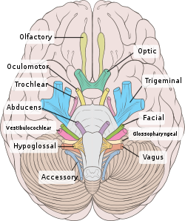

Mental Status
- Patients posture is erect
- Patients movements are voluntary
- Good Hygiene
- Patient dressing is appropriate
- Patient is alert and oriented x3 (person, place and time)
- Give patient some directions such as crumble a paper to see if he/she is able to follow directions.
- Give patient 4 unrelated words and have them repeat to assess for memory
- Assess for suicidal thoughts. Do they have a plan?

Neuro
Assess gait and balance by having patient walk towards you, if able to walk. “NOTE: Gait and balance are smooth, rhythmic, and effortless with an opposing arm swing.”
- Perform Romberg test
- Have the patient sitting down and tell them “can you flip your hands on your knees like this (demonstrate- pat knees with both hands, lift up, turn hands over and pat the knees with the back of your hands (supination and pronation).
  - “Fine motor function intact.”
- Test for light pain/touch
- Test for Stereognosis
  - w/ the patients eyes closed, place familiar object (paperclip) in patients hand. Please tell me what you think it is.
- Test for Grapgesthesia
  - w/ patients eyes closed, trace the number 8 w/ end of the percussion hammer on the middle of patients hand. Patient should tell say number 8.

“Spinothalamic tract in tack as well as sensory function light touch and pain is intact. “
- Have patient touch their nose and then touch your finger
- Plantar Reflex: W/ percussion hammer draw a light stroke up the lateral side of the sole of the foot and inward across the ball of the foot (like an upside-down J). A normal response is plantar flexion of all toes and inversion and flexion of the forefoot. NOTE: negative Babinski sign
