Parenteral Medication (everyone is given 2 medications)

- Wash Hands
- Collect the Physician Order and MAR from professor
- Circle items you will not administer b/c it is not on physician order, initial and write the reason why you are not administering. Contact physician “professor”.
- Research medication Therapeutic Class, use, tests, side effects, etc.
- Place a dot next to the medications you WILL administer
- Sign and date MAR VERIFIED BY
- Present to Professor for confirmation to proceed
- Knock on the patient’s door.
- Introduce yourself
- Verify 2 patient identifiers
- Is patient Alert and Oriented x3? Do you know what day it is? Do you know why you are here?
- Explain that you will be back to administer his/her medication
- “Are you in any pain?”
- “Do you have any allergies?”
- Advise you will be returning shortly.
- Give privacy
- Go wash hands
- Collect the Items on your tray (if you forget something, take the tray with you. Do not leave meds with patient) (Verify medication you are obtaining is correct- 1st check!)
- Items to Collect
  - Tray
  - Gloves
  - Gauze
  - Medication (VERIFY YOU HAVE RIGHT MEDICATIOIN AT THE MED CART!!!)
    - Is the Medication expired?
    - Do you need a pill crusher or pill cutter?
  - Medication Cup (for PO orders) ****If it is PO Liquid, look for liquid.****
  - Water container (for PO orders)
  - Blunt Tip Fill Needle
  - Barrel (according to medication quantity)
    - Needle
      - SUBCUTANEOUS (Blunt tip up)
        - Pinch site of injection
        - 25 Gauge 5/8 length (any length less than 1 inch)
        - 45 degree

SUBCUTANEOUS INJECTION SITES

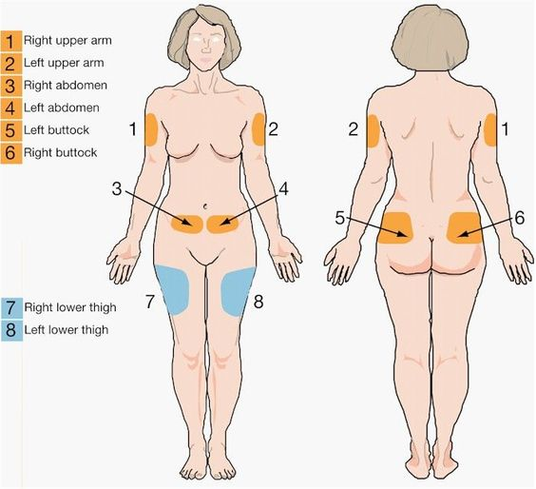
      - Intramuscular (Blunt tip up)
        - 20-25 Gauge 1-1 ½ length
        - 45 and 90 degree (45 and pinch if a skinny person in Deltoid)
        - ASPIRATE!!!!!!! “NO BLOOD DRAWN
        - Vastus Lateralis Site < 3 mL
        - Ventrogluteal Site < 3 mL
        - Deltoid < 2 mL
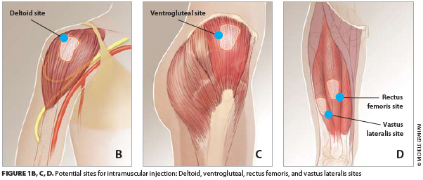

NOTE: if you forget something when you get to your patient, just take the tray with you, and change gloves when you return to the patient.

- Knock on the door
- Verify you are giving correct medication!!!! (2nd check)
- Explain the medication and what it will help do prior to preparing medication.
  - If medication causes dizziness, ask patient to use call light for assistance to bathroom
  - If medication will cause patient to go to the restroom frequently, advise patient to be careful and use call light in case assistance is needed.
- Raise bed to a comfortable working height
- If PO, raise patient to Fowlers 45 degree.
- Verify you are giving correct medication!!!! (3rd check)
- Apply alcohol to the vial and the injection site
- Administer medication ALWAYS ASPIRATE FOR INTRAMUSCULAR
- DO NOT RECAP NEEDLE
- Discard the needles by taking the tray to the Needle Bin.
- Lower the patients bed!!!!!!
- Provide patient with call light and advise when it is important to call YOU!!!
- Remove gloves
- Place a line through the TIME administered, not the medication and INITIAL and mark site code that meds were administered.
- Sign the MAR and date at the bottom
- Ask patient if there is anything else you can assist them with.
- Give patient their privacy
- Wash Hands
- Exit room

DRUG | Therapeutic Effect | Test | Additional Info
Aspirin | Antipyretic  Analgesic |  | Reduces Inflammation, fever  INCREASES BLEEDING WITH HEPARIN  Causes DIZZINESS
Atorvastatin | Lipid Lowering Agent |  | Amnesia, bronchitis, hyperglycemia
Benazepril | Antihypertensive |  | Lowering of BP
Bupropin | Antidepressant  Smoking Deterrent |  | Ask about suicidal/homicidal thoughts
Digoxin | Antiarrhythmic (lowers pulse) | 0.5- 2 ng/ml (nanometer) | If larger than 2,  DO NOT ADMINISTER
Diltiazem | Antiarrhythmic |  | MAY INCRESSE DIGOTIN LEVELS
Dipyridamole | Antiplatelet Agents  Coronary Vasodilators |  | Administer with FULL GLASS OF WATER if PO
Docusate Sodium | Laxative |  | May cause mild cramps, diarrhea
Erythromycin | Antibiotic
Ferrous Sulfate | Antianemic |  | Dark stools, constipation  Take with FULL GLASS OF WATER
Furosemide “Lasix” | Diuretic |  | Blurred vision. Dizziness, headache
Heparin | Anticoagulant | PTT 25-35 second | If higher than 35,  DO NOT ADMINISTER
Hydrochlorothizide | Antihypertensive  Diuretic |  | Dizziness, weakness  Assess patient if giving Digoxin
Levothyroxine | Hormone |  | Assess APICAL pulse prior to administration
Lorazepam | Antianxiety  Analgesic  Sedative |  | Dizziness, drowsiness, lethargy
Metformin | Antidiabetic |  | Management of Diabetes 2
Nitroglycerin | Antianginals |  | Reduction of BP  Increased Cardiac Output  Dizziness
Phenytoin Sodium | Antiarrhythmic  Anticonvulsants |  | SUICIDAL THOUGHTS  Observe for rash
Potassium Chloride | Mineral/Electrolyte Replacement |  | Prevents potassium depletion  PULSE, HEARTBEAT  3-5.5 mEq
Tamazepam
Warfarin | Anticoagulant |  | Assess for bleeding gums, black stools, etc.
Zolpidem | Sedative / Hypnotic |  | Assess for mental status  Do not administer with food  ADVISE if swelling of tongue or throat

