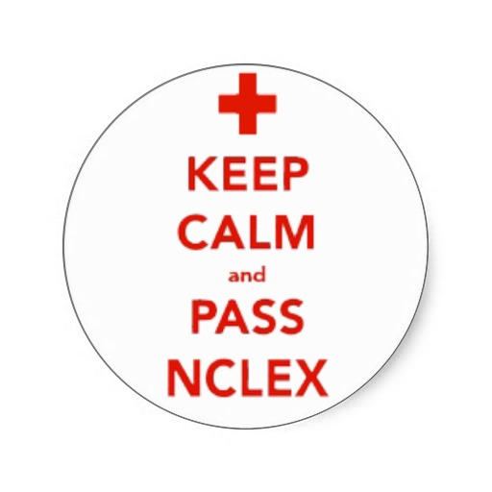
Study Tips for the NCLEX

*The following can be used for either RN or PN, there are no discriminations within these contents.

Let me begin by acknowledging the fact that everyone studies and works differently. What my strategies and methods were may not work for everyone or anyone. However, during my time of studying I did realize that it relieved some of my anxiety to know how others were studying, and their succession on the NCLEX. I hope that my story and studying tips will be enough to ease some of your stress, anxiety, and possible feelings of hopelessness or unworthiness. Good luck on your journey in becoming a nurse!

My brief background:
A 26 y/o single, unmarried female, lives at home with her mother and cat. Graduated May 17th 2009 with a BS in Biology; Graduated August 6th 2013 with a BSN from an accelerated (12-month) program; took the NCLEX-RN 1st time on 11/12/13 and passed! Studied from Oct 3rd to November 11th.

Study Materials:
- Kaplan
  - NCLEX-RN Content Review Guide (free on Amazon)
  - Online materials (paid through the school)
- Saunders Comprehensive Review NCLEX-RN Examination 5th Ed. (yellow book)
- Lippincott’s NCLEX Alternate-Format Questions 4th ed.
- NCLEX Review Made Simple A Thousand Points of Light by: Paul K. Addae, RN
- Free study guides floating around from Allnurses.com
- Hurst Review study guides (every body system, drug prefixes/suffixes, NCLEX review, study tips) from Quizlet.com
- YouTube videos (Anneliese Garrison, Michael Linares (Simple Nursing), and anything posted from a nursing school or health organization)
- Mobile apps (all free):
  - Kaplan NCLEX-RN Mini Qbank
  - NCSBN’s NCLEX Review RX Flash Cards
  - Saunders NCLEX-RN Exam-Lite Mobile Q’s
  - Lippincott’s Q&A (all of them)

I basically focused on the Kaplan materials. I watched some of the content and question review videos, did the Qbank, Sample Tests, and Q Trainers. I would use the study guides as a supplement for reading full-long chapters on content, and I barely touched Saunders. I used Lippincott towards the end because that’s when I needed to practice those kinds of Qs more (after already being comfortable with the multiple choice ones).

Study Schedule/Environment:
- 7-days/WK, 8am-6pm, two 1hr breaks, 3 square meals a day + 2 snacks, lots of fluids (water and orange juice especially), and daily multivitamins.
- Studied at another family member(s)’ house, no access to my favorite video games, no distractions, set my iPhone’s “Do Not Disturb” mode from 8am-7pm every day (I needed some time to myself before texts came in lol), set my schedule reminders on all electronic devices.
- Limited contact with fellow classmates, boyfriend, friends (I warned them all about my studying before I cut them off), deactivated media accounts (Facebook, Twitter, etc), and deleted any apps from my phone that contributed to my distractions.
- Worked per-diem twice a week as a filing clerk, until the last two weeks before my exam when I did not work at all.

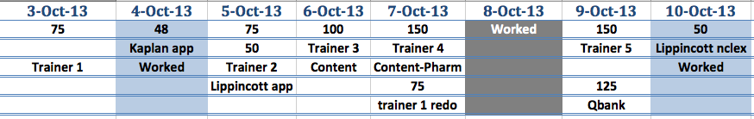

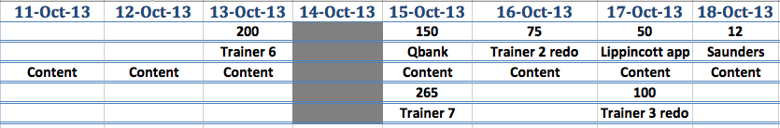

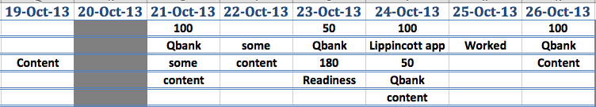

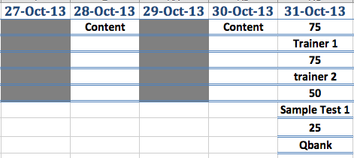
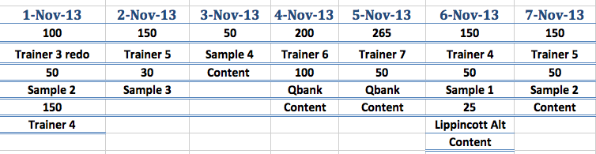
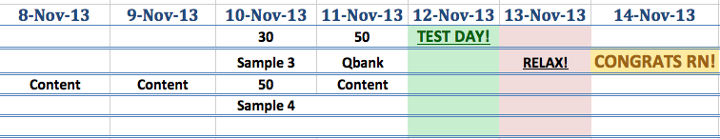

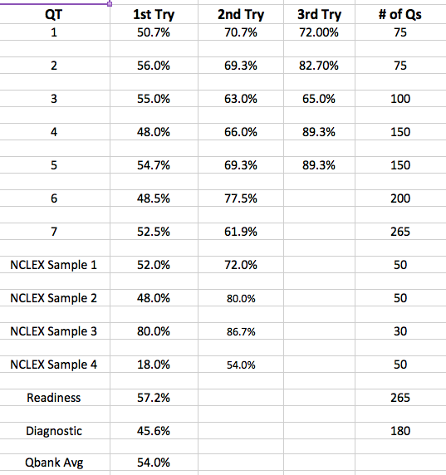

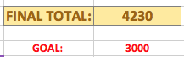

Qbank Cumulative:
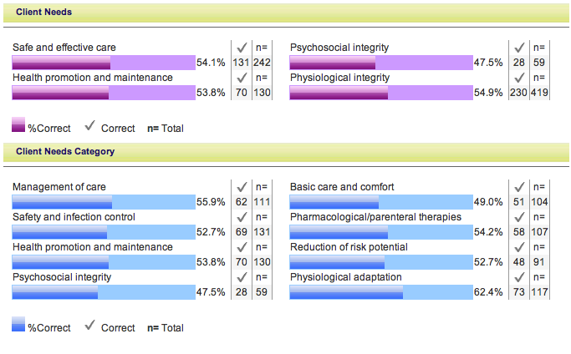

I have to admit that sticking to my study schedule was probably the hardest thing out of this entire process that I had to do. While many people may not have the same luxury as I do in terms of only having the responsibility of studying and passing this exam, it was still hard nonetheless. There were highs and lows in that one month where I fluctuated from feeling positive and confident, to feeling uneasy and pessimistic about taking this test. I wanted to reschedule my exam a dozen times (especially a week before the date), but had some really genuine friends to bring back my confidence.

However, I did not always stick to my study schedule from minute to minute; some days I woke up later than usual, and other times I would just start later because I’d get distracted doing something else. Yet, 80% of the time I did stick to my schedule, I needed to; I wanted to accustom my body to feeling as awake as possible in preparation of my exam date. I would usually start the day doing a question trainer (no reviewing beforehand), then I’d thoroughly reviewed my rationales for ALL of my questions (both wrong and right). I wanted to make sure that I understood why I got something wrong as well as why I got it right. If there were terms, drugs, pathologies, or anything at all that I did not know, was not familiar or comfortable with, I made sure to read on it, Google it, YouTube it, and make charts/diagrams or take notes on it.

When I took my breaks I made sure that I did not think or do anything NCLEX-related. I would watch Netflix (caught up on Scandal, Vampire Diaries, and Breaking Bad), Legend of Korra, The Originals, American Horror Story, or I would play a PC game that I haven’t touched in over a year (Dungeon Defenders).

The whole purpose was to constantly reward myself for understanding and learning concepts, etc. that I was either not knowledgeable about or comfortable with before.
I did go home one weekend to take my cat to the vet and fix my car, which although I hardly got any studying done; was still a productive time spent, so I didn’t feel guilty afterwards. I also went to the Breast Cancer Walk on Sunday, and I planned my studying around that too to make up for the time lost.

Weekend before my Test:
RELAXATION! God bless my aunt because she wanted to ENSURE that I got out from my dungeon of studying and rejoined the world to some degree. She also wanted to make sure that I was well groomed too lol. She bought me a new outfit, treated me to a manicure, pedicure, eyebrows, ice cream, and then colored my hair at home! It felt so good to feel like a person again let alone a woman! I reviewed content when I could, (because the Lord knows that my uncle doesn’t stop his Salsa Music-Saturdays for anyone!)

I also took my last few days before the test to read the entire “NCLEX Review Made Simple” iBook ($3.99). This book really fit my lack of attention span profile! In just 265 single iBook pages I was able to read about the important stuff throughout every body system in addition to some different test-taking strategy tips.
*Note that various study materials will have different lab values, so just stick to one resource for those. Remember that the NCLEX will be obvious enough with high or low values i.e. PCO2 of 56 instead of 46 or 47.

*Keep in mind of the publishing dates! NCLEX-RN changed in April 2013, so brush up on any new protocols posted such as how to remove PPEs (Kaplan & CDC say: Don gown, mask/respirator, goggles/face shield, gloves; Remove gloves, goggles/face shield, gown, mask/respirator. Other sources say to reverse the order of donning)

Testing Day:
One of the most restless nights ever! I went to bed early as planned (9pm, alarm set for 5AM), but waking up at 2:30AM to use the bathroom was a mistake because I couldn’t sleep afterwards! I played a game on my phone, and even reviewed content just to make me sleepy again, but needless to say…it didn’t work . On the way to the testing center (my uncle drove me), I texted back everyone who wished me luck and/or told me they loved me, and I focused on calming down.

Everything went smoothly on the way there, and even throughout the pre-testing process at the center. It almost seemed like destiny to me! The number tag I took to wait my turn was #25 (my birth-day is the 25th), and the number of questions I stopped at was 87 (my birth year).

I took only 2 breaks (1 unscheduled and 1 scheduled (my heart sank when the screen blanked)). I used the bathroom twice, didn’t have a snack, drank 1 cup of water, and regrouped every time I felt that I was rushing, losing control, about to cry, or getting overwhelmed.

Summarized Study Tips:
- Make a schedule that you can realistically stick to, but don’t beat yourself up if you stray here and there
- Don’t compare your progress with others! Everyone works differently and learns differently
- Get enough sleep every day and especially the night before your test
- Eat healthy meals and snacks
- Don’t cram because your brain does not have enough time to process what it learned! UNDERSTAND what you are studying, don’t memorize! Take your breaks (allows the brain to process what you’ve been reviewing)
- Learning the basics and healthy functioning of systems will help you to figure out the rest
- Listen to classical music while sleeping, and while reviewing rationales or studying
- Disconnect from negativity (no matter the source)
- Believe in yourself! You WILL NOT KNOW EVERYTHING so don’t stress yourself to!
- NCLEX is arbitrary! What one person got tested on will be different than yours!

Pearson Vue Trick (PVT):
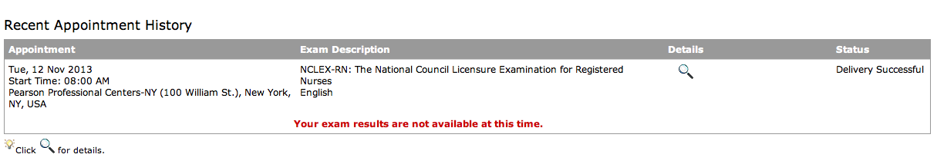
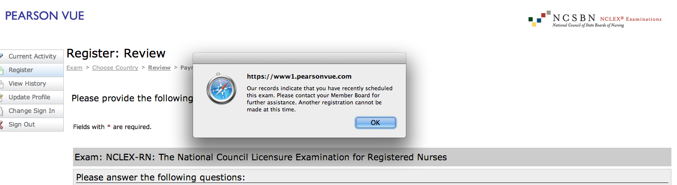
*Make sure your status says “Delivery Successful” before trying the trick.

